**केंद्रीय विद्यालय वायुसेना स्थल ओझर**

**शीतकालीन गृह कार्य(2021-22)**

**कक्षा- छठीं**

**विषय- हिंदी**

**पाठ्य पुस्तक से**

**1**.झांसी की रानी, जो देखकर भी नहीं देखते, संसार पुस्तक है, मैं सबसे छोटी होऊँ, लोकगीत पाठ के कठिन शब्दों के अर्थ प्रश्न उत्तर तथा भाषा की बात अपने अभ्यास कार्य पुस्तिका में पूर्ण करें तथा याद करें।

**2.** बाल राम कथा पाठ्य पुस्तक से सोने का हिरण, सीता की खोज, राम और सुग्रीव, लंका में हनुमान, लंका विजय पाठ पढ़ें।

**व्याकरण**

**1.शब्द युग्म युग्म में अंतर बताते हुए वाक्य प्रयोग करें-**

अवधी -अवधि

और - ओर

मैं - में

दिन - दीन

मेल - मैल

सिल - शील

**2. निम्नलिखित संज्ञा शब्दों में ईला प्रत्यय जोड़कर विशेषण बनाइए-**

पत्थर, कांटा, रस, जहर

**3.10 विलोम शब्द लिखो।**

**4. कारक चिन्ह का प्रयोग करते हुए नीचे लिखे हुए अनुच्छेद को पूर्ण करें।**

तुरही भारत के कई प्रांतों में प्रचलित है। यह दिखने ........अंग्रेजी के एस या सी आकार तरह होती है। भारत........ विभिन्न प्रांतों में पीतल या कांसे .........बना यह वाद्य अलग-अलग नामों...... जाना जाता है। धातु की नली .......घुमाकर एस........ आकार इस तरह दिया जाता है कि उसका एक सिरा संकरा रहे और दूसरा सिरा घंटीनुमा चौड़ा रहे। फूंक मारने...... एक छोटी नली अलग...... जोड़ी जाती है। राजस्थान .......इसे बर्गू कहते हैं। उत्तर प्रदेश..... यह तूरी, मध्य प्रदेश और गुजरात....... रणसिंघा और हिमाचल प्रदेश..... नरसिंगा नाम से जानी जाती है। राजस्थान और गुजरात........ इसे काकड़सिंघी भी कहते हैं।

**5. निम्नलिखित में लिंग (स्त्रीलिंग या पुल्लिंग) की पहचान करो-**

बालिका, स्त्री, नाना, गुरु, दादी, बच्चा, शेर, हाथी, दादा।

**लेखन कार्य**

**1**.शुल्क माफी हेतु प्राचार्य को प्रार्थना पत्र लिखिए।

**2.**मेरा परिवार विषय पर निबंध लिखिए।

**कक्षा सातवीं**

**विषय हिंदी**

**पाठ्य पुस्तक से**

**1.** कंचा, एक तिनका, खान पान की बदलती तस्वीर, नीलकंठ, भोर और बरखा पाठ के कठिन शब्दों के अर्थ, प्रश्न-उत्तर, एवं भाषा की बात कार्यपुस्तिका में पूर्ण करके याद करें।

**2.** बाल महाभारत के यक्ष प्रश्न से अभिमन्यु वध तक के पाठ का स्वाध्ययन करें।

**व्याकरण-**

**1.**निम्नलिखित मुहावरों का अर्थ बताते हुए वाक्य प्रयोग करें-

दाँतों तले उँगली दबाना

हक्का-बक्का रह जाना

विस्मित होना

साँस रोके हुए

प्राण सूख जाना

**2.**द्वंद समास के 10 उदाहरण लिखिए।

**3.**दीर्घ संधि की परिभाषा लिखते हुए निम्नलिखित शब्दों में संधि कीजिए।

नील +आभ

नव +आगंतुक

सिंह+आसन

मेघ +आच्छन्न

विद्या+आलय

**लेखन कार्य**

1-अनुच्छेद लेखन-अनुशासन का महत्व

ग्लोबल वार्मिंग

2-पत्र लेखन

बोर्ड परीक्षा में प्रथम आने पर अपने मित्र को बधाई पत्र लिखिए।

योग का लाभ बताते हुए अपने भाई को योग शुरू करने के संबंध में पत्र लिखिए।

**कक्षा आठवीं**

**विषय हिंदी**

**पाठ्य पुस्तक से-**

**1**-कामचोर, जब सिनेमा ने बोलना सीखा सुदामा चरित, जहां पहिया है, अकबरी लोटा, सूर के पद पाठ के कठिन शब्दों के अर्थ प्रश्न-उत्तर तथा भाषा की बात कार्यपुस्तिका में पूर्ण करें तथा याद करें।

**2-**भारत की खोज पुस्तक में युगों का दौर और नई समस्याएं पाठ पढ़ें।

**व्याकरण**

**1**-उपसर्ग- बे,प्र,आ,भर,बद,से,सु,अभि,अनु,परि,वि उपसर्ग का प्रयोग करके पांच नए शब्द बनाइए।

**2**-प्रत्यय- आ, कार, ई, इक, वाला, ता, ना प्रत्यय का प्रयोग करके पांच नए शब्द बनाइए।

**3**-20 विलोम शब्दयुग्म लिखिए।

**4**-निम्नलिखित मुहावरों का प्रयोग अर्थ स्पष्ट करते हुए अपने शब्दों में प्रयोग करें-

आंखों से खा जाना,

आंख सेकने के लिए भी ना मिलना,

चैन की नींद सोना,

मारा मारा फिरना,

पीठ ठोकना,

डींग हांकना।

**लेखन कार्य**

1-विद्यालय हेतु खेल सामग्री खरीदने के लिए प्राचार्य को प्रार्थना पत्र लिखिए।

2-निम्नलिखित विषय पर निबंध लिखिए-

पर्यावरण प्रदूषण

विज्ञान के चमत्कार

**केंद्रीय विद्यालय वायु सेना स्थल ओझर नासिक**

**शीतावकाश गृहकार्य सत्र 2021-22**

**(22/12/2021 से 01/01/2022)**

**कक्षा- IX**

1. ‘रीढ़ की हड्डी’ एकांकी के आधार पर लिखिए कि वर्तमान युग में लड़का-लड़की में समानता लाने के लिए क्या कदम उठाए जाने चाहिए ? आप इसमें अपना योगदान कैसे दे सकते हैं ?
2. कवि माखनलाल चतुर्वेदी जी के बारे में बताते हुए उनकी किसी एक कविता के बारे में लिखिए |
3. ‘प्रेमचंद के फटे जूते’ पाठ के आधार पर बताइये कि इस पाठ में समाज की किस प्रवृति पर करारा व्यंग्य किया गया है |
4. स्वास्थ्य ख़राब होने के कारण आपके मित्र की परीक्षा की तैयारी ठीक ढंग से नहीं हो पाई है, जिसके कारण वह हतोत्साहित है | आप उसका उत्साहवर्धन करते हुए संवाद कीजिए |
5. निम्नलिखित में से किसी एक विषय पर 120 शब्दों में अनुच्छेद लिखिए –
6. **स्वच्छता अभियान**- भूमिका,स्वच्छता की आवश्यकता, लाभ, सुझाव, निष्कर्ष
7. **स्मार्ट फोन का छात्रों पर बढ़ता प्रभाव**- भूमिका, आवश्यकता एवं लाभ, दोस्तों पर प्रभाव डालना, दुष्प्रभाव, उपसंहार

**कक्षा- X**

1. ‘उत्साह’ कविता के आधार पर बताइए कि बादलों से हमें क्या प्रेरणा लेनी चाहिए ?
2. लोग यथार्थ को स्वीकार करने से क्यों डरते हैं | ‘लखनवी अंदाज’ पाठ के आधार पर लिखते हुए अपने विचार भी लिखिए |
3. समाचार पत्रों की जन-जागरण में क्या भूमिका होती है ? ‘जॉर्ज पंचम की नाक’ पाठ के आधार पर स्पष्ट कीजिए |
4. ‘सरस्वती’ नाम से नया स्कूल खुला है | उसमें कक्षा 1 से 12 तक पढ़ाई का प्रबंध है | दाखिले शुरू हैं | कुछ विशेषताएँ लिखते हुए विज्ञापन तैयार कीजिए |
5. निम्नलिखित में से किसी एक विषय पर 120 शब्दों में अनुच्छेद लिखिए –
6. **मेरी दिनचर्या**- प्रस्तावना, व्यस्तता में आनंदानुभुति, दिनचर्या में स्वास्थ्य लाभ, व्यवस्थित जीवन और प्रगति, उपसंहार |
7. **खेल और स्वास्थ्य**- प्रस्तावना, खेल स्वास्थ्य और भौतिक सुख, खेल के साधन, उपसंहार

शीत कालीन अवकाश गृहकार्य सत्र 2021-22 ( हिन्दी )

**कक्षा बारहवीं**

1. कोरोना के बढ़ते मामलों को ध्यान में रखते हुए आप के शहर के अस्पताल के प्रबंधन पर असंतोष व्यक्त करते हुए अस्पताल के चिकित्सा अधीक्षक को पत्र लिखिए |
2. किसी राष्ट्रीय दैनिक समाचार – पत्र के संपादक के नाम एक पत्र लिखिए , जिसमें महामारी के काल में बढ़ती महंगाई से जूझते लोगों की कठिनाइयों का वर्णन हो |
3. किसी राष्ट्रीय दैनिक समाचार – पत्र के संपादक के नाम एक पत्र लिखिए , जिसमें महामारी के काल में बढ़ती महंगाई से जूझते लोगों की कठिनाइयों का वर्णन हो |
4. ‘फास्ट फूड के दुष्प्रभाव’ पर एक फीचर लेखन लिखिए|
5. दिए गए विषय के अनुसार परियोजना कार्य पूर्ण करें

**कक्षा ग्यारहवीं**

1. लगभग 150 शब्दों में रचनात्मक लेख लिखिए

I. मेरे आदर्श

II. सुखद घटना जिसने मुझे नई सीख दी

2. खाद्य पदार्थों में मिलावट की बढती प्रवृति पर चिंता व्यक्त करते हुए किसी प्रतिष्ठित समाचार पत्र के सम्पादक को पत्र लिखिए |

3.आप किसी स्थान विशेष की यात्रा करना चाहते हैं | उस स्थान की जानकारी प्राप्त करने की लिए पर्यटन विभाग के अधिकारी को पत्र लिखिए |

4 . ‘राजस्थान की रजत बुँदे इस पाठ को पढ़कर उसपर 20 बहुविकल्पी प्रश्न तैयार कीजिए ।

5 दिए गए विषय के अनुसार परियोजना कार्य पूर्ण करें ।

**KENDRIYA VIDYALAYA, AFS, OJHAR**

**WINTER BREAK HOLIDAY HOMEWORK (2021-22)**

**CLASSES VI TO VIII English**

**(General instruction: Students will write down their answers in their classwork notebook.**

**Note: Answer Key will be provided after reopening of school to cross check your answers.)**

**READING UNIT – 1**

**Debate: Religion and Politics Should Not Be Mixed**

“Religion and politics must be kept separate. Religion is meant to unite people with similar beliefs into a moral community. Politics, on the other hand, is meant to unite all people of a region into a single community, regardless of personal beliefs and practices. Thus, when the two are mixed, the results are bound to be disastrous”.

* **Daniel**

“I believe that religion is something that helps you or guides you towards the path of eternal peace and serenity. We live in a country that has great religious diversity. Every religion in this world focuses on one thing that is, life is a give and take relationship. The way you behave with others is the same that you should expect from others.

Politics in India nowadays has started using religion as one of its manifestations which is not at all good for the future of this country because it acts as a barrier in the growth of the country.  
The leading political figures of our country should not indulge in religious debate in politics in order to satisfy their greed for power rather they should focus on inculcating the values highlighted by the religions into the day to day life of people. This will not only help them side by side it will also make this country a good place to live in.

* **Helly**

Religion introduced in politics is not bad, but Politicians use it for their own purpose, this is bad. Misuse of religion for political gain is wrong. This creates conflict among people and is against the principles of any religion. Religion’s actual meaning is to connect people and advocate peace and love for everyone. If religion is mixed in politics for good purpose, then no one will think that it is bad.

* **Vivek**

I think religion and politics should go hand in hand. We as Indians live our daily lives according to our religion then why should we separate it when it comes to politics. Politics is a part of our life and when the rest of our lives are based on religion then politics should also involve religion. Religion teaches us honesty, sincerity and victory of good against evil. If politics does not have religion, it means that it won't have these guiding principles which will further lead to more corrupt political systems.

And practically you can't keep them apart. Religion and politics cross over into each other every day. We need to accept it that there is absolutely no way to separate them entirely.

* **Arjun**

**Source: Internet**

**Q1. Debate**

**Which one of the speakers most directly opposes the mixing of religion and politics?**

1. Daniel.
2. Helly
3. Vivek
4. Arjun

**Q2.  Which of the following questions do the students seem to be responding to?**

1. **Do you agree religion is a major political issue facing the world today?**
2. **Are you in favour of separating religion and politics?**
3. **Do you believe politics should interfere in religious practices?**
4. **What is the role of religion in politics?**

**Q3: Debate**

**Thinking about the main ideas presented by the four participants, which participant do you agree with most strongly?**

**Participant’s name: ...............................................**

**Using your own words, explain your choice by referring to your own opinion and the main ideas presented by the student.**

**………………………………………………………………………………………………………………………………………………………………………………………………………………………………………………………………………………………………………………………………………………………………………………………………**

**Q4. Given below are some statements based on the ideas and values of the participants. Match the statements with the names of the participant. The first one has been done for you.**

|  |  |
| --- | --- |
| **Statement** | **Name of speaker** |
| **Mixing religion and politics would be dangerous** | **Daniel** |
| **Religion and politics cannot be completely separated** |  |
| **Religion should be inculcated in the daily life of people** |  |
| **Using religion for political advantage is against the basic ideas of any religion** |  |

**READING UNIT – 2**

**HISTORY OF POSTAL SYSTEM**

Before the advent of the modern postal system and the [penny black](https://en.wikipedia.org/wiki/Penny_Black) in 1840, sending letters was generally very expensive. In 1830 the post was very much the province of the wealthy few and the charges were paid by the recipients of the mail, not the senders. If you were a polite letter-sender, you would often include some coins inside your letter to help repay the cost of your recipient receiving it. Poorer people developed ways of getting around this entirely, as is recounted in Harriet Martineau's *A History of England During the Thirty Years' Peace* (1849).

*"Mr Rowland Hill, when a young man, was walking through the Lake District when he one day saw the postman deliver a letter to a woman at a cottage door. The woman turned it over and examined it, and then returned it, saying that she could not pay the postage, which was a shilling. Hearing that the letter was from her brother, Mr Hill paid the postage, in spite of the manifest unwillingness of the woman. As soon as the postman was out of sight, she showed Mr Hill how his money had been wasted, as far as she was concerned.*

*"The sheet was blank. There was an agreement between her brother and herself, that as long as all went well with him, he should send a blank sheet in this way once a quarter; and thus she had tidings of him without the expense of postage.”*

Most people would have remembered this incident as a curious story to tell, but Mr. Hill's was a mind which wakened up at once to a sense of the significance of the fact. There must be something wrong in a system which drove a brother and sister to cheating, in order to gratify their desire to hear of one another's welfare.

Of course, there were loopholes for the rich: Royals, aristocrats, and eventually, MPs were able to 'frank' their mail. Such a person could sign his name across the back of the envelope, a gesture of dominion that meant that his letters travelled free of charge in the postbag. Needless to say, franking was a privilege that allowed for extensive and costly abuses. Two of the most notorious fraudulent frankers were the poets Percy Bys she Shelley and Samuel Taylor Coleridge. They would approach MPs, pleading extreme poverty, and persuade them to sign the backs of their letters. Shelley also forged the signature of his own father, who was an MP.

**Source: (“Franking.” *Bizarre Victoria*, 21 Aug. 2015, bizarrevictoria.wordpress.com/2015/08/21/franking/.)**

Task 1: The woman returned the letter to the postman because:

Choose the correct option:

1. She could not pay the postage
2. The letter was not addressed to her
3. She already knew the contents of the letter
4. She hated the person who wrote the letter

Response: ___

_____________________________________________________________________________

Task 2: The agreement between the woman and her brother in the story was

Response:

________________________________________________________________________________

Task 3: The most striking feature of old postal system was :

Choose the correct option:

   a.) People loved to send mails.

   b.) The charges of the mails were paid by the recipient.

  c.) People did not need mails.

  d.) They wanted to give due respect to the senders.

Response: ____

____________________________________________________________________________

Task 4: Name the poets mentioned in the passage who were fraudulent frankers.

Response: _

_______________________________________________________________________________

Task 5: Give a synonym for ‘forged’.

Choose the correct option:

1. Imitate
2. (b) fake
3. (c) mimic
4. (d) oppose

Response: ______________

A: Formal Letters.

1. Write an application for a week’s leave to the principal of your school as you are unable to attend the school because of viral fever.

2) Write an application to the Principal of your school for change of the section.

1. : Paragraph writing.

Write a paragraph in about 150-200 words on each of the following topics.

* 1. Value of games and sports.
  2. Freedom is life.

**KENDRIYA VIDYALAYA, AFS, OJHAR**

**WINTER BREAK HOLIDAY HOMEWORK (2021-22)**

**CLASSES IX & X**

**( General instruction : Students will write down their answers in their classwork notebook.**

**Note: Answer Key will be provided after reopening of school to cross check your answers.)**

**READING UNIT – 1**

**Floating on the Dal Lake in Srinagar, a post office like no other**

**(Source: www.hindustantimes.com)**

The turquoise waters of Srinagar’s Dal Lake glisten in the spring sun, reflecting in between quaint ripples the grand Himalayan peaks that dominate the horizon. Here, amidst scores of docked houseboats and bright yellow shikaras ferrying tourists and locals alike, floats a most unexpected government centre – a post office.

The “Floating Post Office, Dal Lake” – claimed to be the only such in the world – is built on an intricately carved maroon houseboat, now moored on the western edge of the Dal Lake.

This post office lets you avail all the regular postal services available in the country while being afloat. The seal used on everything posted from the Floating Post Office is unique – along with the date and address, it bears the design of a boatman rowing a shikara on the Dal Lake.

“This is actually a heritage post office that has existed since British times. It was called Nehru Park post office before 2011. But that year, the then chief post master John Samuel took an initiative to repurpose it and rename it as ‘Floating Post Office’,” said Surinder Kaul, a sub postmaster who runs the post office.

In August 2011, the Floating Post Office cum Museum was formally launched by then chief minister Omar Abdullah and Union minister of state for communication and IT, Sachin Pilot.

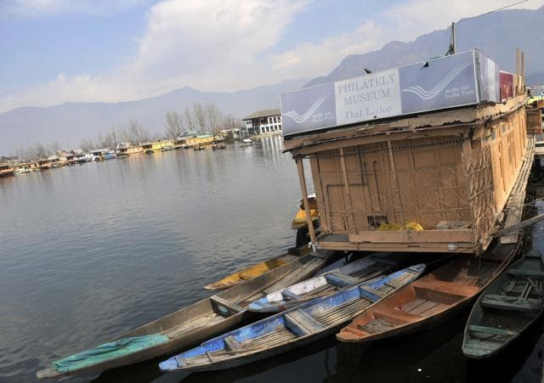

The post office also has a Philately museum. (Waseem Andrabi / HT Photo )

**Philately museum**

The post office’s houseboat has two small rooms – one serves as the office and the other a small museum that traces the philatelic history of the state postal department.

Farooq Ahmad Khan, a grade four employee who assists Kaul, says many tourists staying on houseboats on the Dal Lake row to the post office everyday to send special postcards back home.

One such postcard, deposited hours ago and lying on the office desk, is written by a certain David to his relatives in London.

He writes, “Lake Dal is idyllic. I’m living in a houseboat owned by a Muslim family, who have rented it for a good price. Next week, I will hire horses and trek up the Kashmir Valley. Best wishes.”

But for the locals, the Floating Post Office is more than an object of fascination. Kaul says Rs 1-2 crore is deposited per month at the Floating Post Office by communities living in and around the Dal Lake.

The lake has several islets that are home to more than 50,000 people.

“For Dal residents, this is where we complete our normal post office work, including banking. Labourers and farmers working nearby and those who run the shikara business all come to this post office to deposit their savings. This is the nearest post office for us,” says Mohammad Ibrahim Bhatt, a Dal dweller who runs a snacks shop on nearby Boulevard Road.

So, are there any problems in running a post office on water? For Kaul and Khan, who have been managing the centre for more than two years now, the greatest fear is the recurrence of 2014-like floods.

“The houseboat had gone for a toss, uncontrollably propelled by the deluge,” says Khan. “Rescue teams had to anchor it using special mechanism on nearby highland. And then, we brought it back on the Dal after the water receded.”

And, what are the boons? “At no time of the year do you need a fan in this post-office!” exclaims Kaul.

**Questions:**

Q1. Why is the post office on Dal lake called the ‘Floating Post Office’?

………………………………………………………………………………………………………………………………………………

Q2. Which new attraction, the first in the country has been opened for the tourists in Jammu and Kashmir?

a) A floating ATM

b) A floating bank

c) A floating post office

d) A floating museum

Q3. Which of the following is the closest in meaning of the word ‘fascination’?

a) passion

b) obsession

c) interest

d) attraction

Q4.  What is the biggest boon of the ‘Floating Post Office’?

…………………………………………………………………………………………………………………………………

Q5. What is the greatest fear related to the ‘Floating Post Office’?

……………………………………………………………………………………………………………………………………

**READING UNIT – 2**

**IF I RETURN THIS TIME**

If I return this time I must return greater.

Not with pointed moustaches

Twisted silly on the face

Not with tails of steel

Tied to my waist

I will give way to others

And not give tigerish

Devouring looks to them If I return

I must return more human.

Stepping out of home

Walking on the roads

Boarding buses Catching trains

If I survive the fate

Of a run-over puppy I must return

More thankful this time

Not just licking my wounds

But caring for all

Completely human If I return at all

Source : No other world selected by Kunwar Narain

**1. What according to you is the central idea of the poem?**

(a) To be more self centered.

(b) To be more self sufficient.

(c) To be more considerate.

(d) To be more care free.

**2. The word 'survive' refers to.**

(a) To be brave.

(b) To be dead.

(c) To continue to exist.

(d) To grow.

**3. According to the first stanza, what does the poet does not want to be** :

(a) Someone who is threatening

(b) Someone who is caring.

(c) Someone who is mad.

(d) Someone who is kind.

**4. What does the repetition of the word if suggest?**

(a) The poet's anger

(b) The poet's love

(c) The poet's irritation

(d) The poet's uncertainty

**READING UNIT – 3**

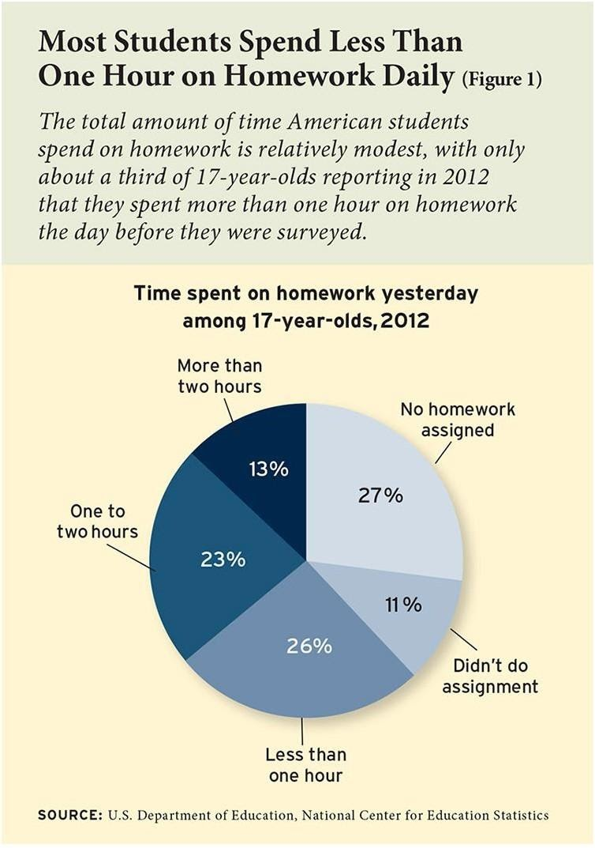

**Q1: How many percent of American students don’t spend their time on homework?**

**a.52% b.62% c.38% d.11%**

**Q2: How many percent of the American students spend more than one hour on homework?**

**i) 13% ii) 23% iii)36% iv)26%**

**a. (i) b. (ii) and (iv) c. (i) and (ii) d. (i), (ii) and (iii)**

**Q3: What can be the main reason behind most students of America not spending their time on homework?**

…………………………………………………………………………………………………………………………….

…………………………………………………………………………………………………………………………….

…………………………………………………………………………………………………………………………….

**Q4: How does homework benefit students?**

**………………………………………………………………………………………………………………………………………………….**

**…………………………………………………………………………………………………………………………………………………….**

**Q5: What can be the bad effect on those students who spend too much time on their homework?**

**…………………………………………………………………………………………………………………………………………………..**

**…………………………………………………………………………………………………………………………………………………….**

**READING UNIT – 4**

**CULTURAL CURRY**

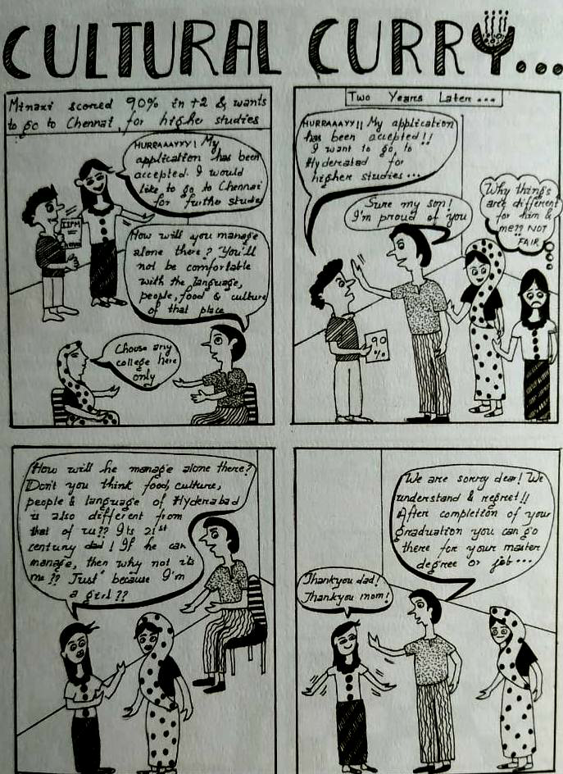

**Source: AEP Manual**

**1.1) The comic talks about a very relevant social problem that we see happening sometimes in our homes or in our neighbourhood. What does the comic strip talk about?**

**a) Dowry system**

**b) Gender discrimination**

**c) Domestic violence**

**d) Illiteracy**

**1.2)  Despite being older, Minaxi was not allowed to go to a different city to study. What reasons do you believe prompted this behaviour from the parents?**

**1.3) Any action that specifically denies opportunities, privileges, or rewards to a person (or a group) irrespective of their merit can be dangerous. Mention any two ways how the lives of girls or women are affected because of these actions?**

**KENDRIYA VIDYALAYA AFS OJHAR**

**WINTER BREAK HOLIDAY HOMEWORK 2021**

**Class XI English**

==================================================================================

1 Poster-

Design posters on the following topics.

1. Effects of junk food
2. Azadi Ka Amrit Mahotsav
3. Blood Donation
4. Save Rivers Campaign

2. Official Letters

Write a letter to the Director of The Sandeep Language Institute enquiring about a Course in German language. Enquire about available batches, duration, Fees and concession.

3. Official Letters

You are Sudha / Sudhir. Write a letter to the Principal of your school about the necessity to start Career Counselling Workshops/ Seminars in your school. Mention how such workshops will improve the confidence among students to choose different career paths.

4. Write Debate on the following topics in favour or against the motion.

1. The Internet can replace a classroom teacher

2. We have Indian body but Western Psyche and Soul

3. Career Courses in Humanities provide a better scope in Career than Sciences.

Submission Date : 03/01/2022

***********************************************************************

KENDRIYA VIDHYALAYA AFS OJHAR

SOCIAL SCIENCE WINTER BREAK HOLIDAY HOMEWORK 2021-22

CLASS VI

Holiday home work is to be done in homework part of your class work copy

Answer the following Questions

Q1 Compare the work of Gram panchayat and Municipal corporation

Q2 Write a note on the work of Patwari

Q3 What is the work of a Tehsildar

Q4 Why is Northern hemisphere called a land hemisphere

Q5 What are the four major domains of earth

Q6 Write the uses of mountains

Q7 Why are river plains thickly populated?

Q8 Why did kings wanted to control the silk route?

Q9 List any TEN things you buy from a market .which of these are made in the areas where you live and which were brought by traders from other areas

Q10 Prepare a genealogy chart for yourself including the family members from different generations

You can make a chart and paste their photographs with their names and relation with you.

Q11 On the outline map of world ,mark all continents and oceans using beads, seeds ,pieces of old clothes or other materials available in your house

Identify and mark India with different colour .

(Use blue colour for waterbodies and different colours and materials for continents)

12.What are the problems that Ashok wanted to solve by introducing dhamma?

Q 13 Look the following pictures/images from A to E carefully.

Identify the land form shown here and write 2 sentences about each.

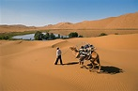 fig A Fig b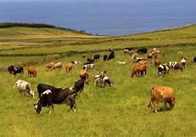Fig c

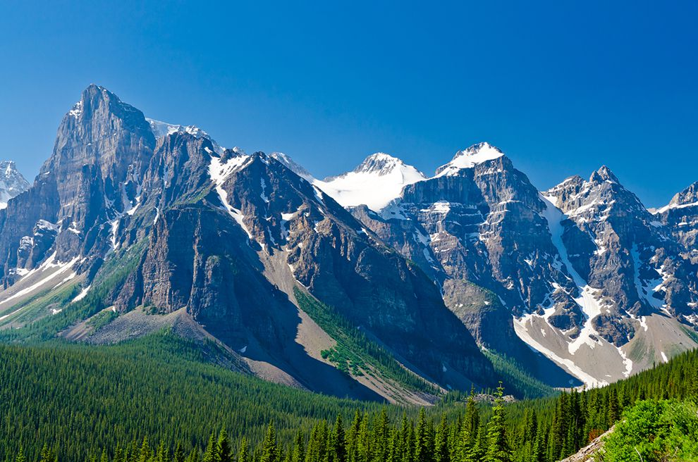fig D

Fig E

**SUBJECT SOCIAL SCIENCE**

**CLASS VII**

**Answer the following questions**

**Note Write the solutions in homework part of your class work copy**

**Q**1 In what ways is a hawker different from a shop owner?

Q2 Imagine that you are a member of a nomadic community that shifts their house every three months, How would this change your life . Explain your views

Q3 What were the ideas expressed by Kabir?

Q4What were the major teachings of Guru Nanak

Q5 How was the administration of Ahom state organised?

Q6 What are the four means of transport. Explain their advantages and disadvantages in two or three sentences.

Q7 What is communication? Prepare a table showing old and modern means of communication

Q8 Find out the names of newspapers and TV channels in English. Hindi and any two regional languages

Q9 Make a collage of any 10 places of attraction in India and explain few sentences about their importance.

Q10 On the outline political map of India, plot states where any 5 major tribal groups live

For eg Gurjars ,Bakarwals,Bhils,Santhals.gonds,ahoms etc

Use different colour beads ,pieces of cloth or any other materials available in your home to locate the above

Q11 Explain the different types of markets you find in your neighbourhood with the help of pictures.

Kendriya Vidyalaya A.F.S Ojhar

(Mumbai Region)

WINTER BREAK HOLIDAY HOMEWORK

Class VIII

Subject: Social Science

Instructions: -

1. All the questions are compulsory.

(2)Holiday Homework should be completed on Home Work Notebook.

(Very Short answers )

1. Write any two reasons for land degradation today?.

2. Suggest three ways to conserve water. ?

3. Why were ryots reluctant to grow indigo?

4. Explain the system of “subsidiary alliance”.?

5. Why did the British preserve official documents?

6. What is the Role of the Public Prosecutor?.

7. Define the term Judicial Review?

8. Who is allowed to vote  in India?

9. What is Indian Secularism?

10. Why does a democratic country need a Constitution?

(Short Answers )

11. Write in your own words what you understand by the term the ‘rule of law’?

12. Name two regions rich in natural gas resources.? 13. Name any three common minerals used by you every day?

(Long Answers)

14. Why did William jones feel the need to study Indian History,Philosophy and Law?

15. Why do Adivasi activists, including C.K. Janu, believe that Adivasis can also use this 1989 Act to

fight against dispossession? Is there anything specific in the provisions of the Act that allows her to

believe this?

16. what you understand by the word ‘marginalisation’?Explain?

17. What is shifting cultivation? What are its disadvantages?

18.Prepare A project on Orrisa Culture and Heritage?

**Kendriya Vidyalaya A.F.S Ojhar**

**(Mumbai Region)**

**WINTER BREAK HOLIDAY HOMEWORK**

**Class IX**

**Subject: Social Science**

**Instructions: -**

1. **All the questions are compulsory.**

**(2)Holiday Homework should be completed on Home Work Notebook.**

**Very Short answers**

**1. What is Subsistence crisis ?.**

**2. Why did the Tsarist autocracy collapse in 1917 ?**

**3. What is the bhabar?**

**4. Why does India have a monsoon type of climate?**

**5. Define an ecosystem.?**

**6. What is a bio-reserve? Give two examples..**

**7. What do you understand by 'people as a resource'?.**

**8. Who are the poorest of the poor?**

**9. What is Universal Adult Franchise?**

**10. Who is the Supreme Commander of the Defence Forces of India?**

**(Short Answers )**

**10. How would you explain the rise of Napoleon?**

**11. Why has India a rich heritage of flora and fauna? 12. Name the three major divisions of the Himalayas from north to south.?**

**(Long Answers)**

**13 What are Jet streams and how do they affect the climate of India?**

**14 Distinguish between Political Executive and Permanent Executive?**

**15. Which capital would you consider the best — land, labour, physical capita and human capital? Why?**

**16. Discuss the major reasons for poverty in India. ?**

**17.Prepare A project on Orrisa Culture and Heritage?**

**KENDRIYA VIDYALAYA A.F.S. OJHAR, NASHIK**

**WINTER-BREAK HOLIDAY HOMEWORK 2021-22**

**SUB-SOCIAL SCIENCE**  **CLASS –XTH**

**ASSIGNMENT**

Map Work

1)HISTORY- A) on the outline map of India political locate the all four Indian national congress session’s place.

B) on the outline map of India political locate any 6 important centers of Indian- national movement.

2)GEOGRAPHY-A) on the outline map of India political show the major soil types of India.

B) On the outline map of India political locate any 8 big dams of India.

c)on the outline map of India show the major producing area of- rice, wheat, sugarcane, tea, coffee, rubber, cotton, jute.

d)on the outline map of India political locate-i) the major mines area of iron ore, coal mines, oil field, mica deposit ii) power plant (nuclear)

e) on the outline map of India political show/ locate the major cotton textile industries, iron and steel plant, software parks.

f) on the outline map of India political locate the golden quadrilateral, north south corridor, east west corridors.

g) on the outline map of India political locate the i) any 5 major ports ii) any 5 international airports.

3) CIVICS: prepare charts containing following columns: -

|  |  |  |  |  |  |  |
| --- | --- | --- | --- | --- | --- | --- |
| S.N. | Name of national/ regional political parties | Name of founder | Year of foundation | Election symbol | State where party is active | Name the present president of party |
| 1 |  |  |  |  |  |  |
| 2 |  |  |  |  |  |  |
| 3 |  |  |  |  |  |  |

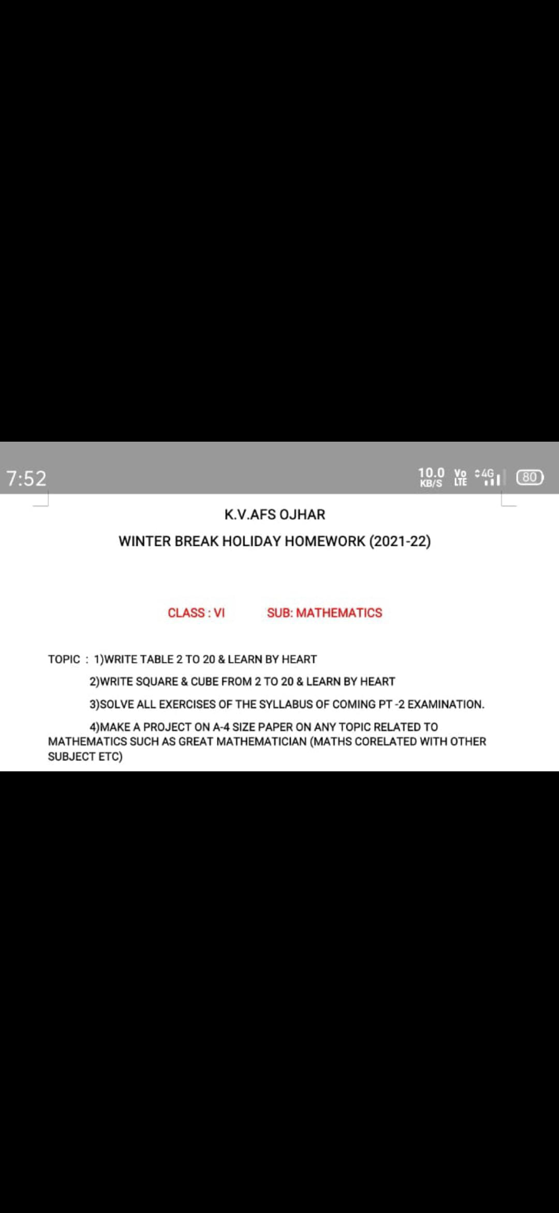

**KENDRIYA VIDYALAYA AFS, OJHAR.**

**HOLIDAYS HOME WORK**

**CLASS – VII**

|  |  |  |
| --- | --- | --- |
| CHAPTER 9 | CHAPTER 10 | CHAPTER 11 |
| MCQ | MCQ | MCQ |
| Question 1. The numerator of the rational number 3/5 is (a) 3 (b) 5 (c) 2 (d) 8  Question 2. The numerator of the rational number 1/100 is (a) 100 (b) 1 (c) 10 (d) 99  Question 3. The denominator of the rational number 4/7 is (a) 7 (b) 4 (c) 3 (d) 11  4.The denominator of the rational number 7/13 is (a) 13 (b) 7 (c) 6 (d) 91 5.The numerator of the rational number −3/4 is (a) -3 (b) 3 (c) 4 (d) -4  6.The sum of 5/4 + (−25)/4 = ………………… (a) -5 (b) 5 (c) 4(d) -4  7.The denominator of the rational number 5/−3 is (a) 5 (b) -3 (c) 3 (d) 8  8.The denominator of the rational number 3−7 is (a) 7 (b) -7 (c) 3 9.The numerator of the rational number −2−5 is (a) 2 (b) -2 (c) 5 (d) -5  10.the numerator of the rational number −5−3 is (a) -5 (b) 5 (c) -3 (d) 3  d) -3 | Question 1. In ΔRST, R = 5 cm, and ∠SRT = 45° and ∠RST = 45°. Which criterion can be used to construct ΔRST? (a) A.S.A. criterion (b) S.A.S. criterion (c) S.S.S. criterion (d) R.H.S. criterion  Question 2. Identify the criterion of construction of the equilateral triangle LMN given LM = 6 cm. (a) S.A.S. criterion (b) R.H.S. criterion (c) A.S.A. criterion (d) S.S.S. criterion  Question 3. The idea of equal alternate angles is used to construct which of the following? (a) A line parallel to a given line (b) A triangle (c) A square (d) Two triangles  Question 4. A Given AB = 3 cm, AC = 5 cm,and ∠B = 30°, ΔABC cannot be uniquely constructed, with AC as base, why? (a) Two sides and included angle are given. (b) The other two angles are not given. (c) The vertex B cannot be uniquely located. (d) The vertex A coincides with the vertex C.  . | Question 1. Perimeter of a square = (a) side × side (b) 3 × side (c) 4 × side (d) 2 × side  Question 2. Perimeter of a rectangle of length l and breadth b is (a) l + b (b) 2 × (l + b) (c) 3 × (l + b) (d) l × b  Question 3. Area of a square = (a) side × side (b) 2 × side (c) 3 × side (d) 4 × side  Question 4. Area of a rectangle of length l and breadth b is (a) l × b (b) l + b (c) 2 × (l + b) (d) 6 × (l + b)  Question 5. Area of a parallelogram = (а) base × height (b) 12 × base × height (c) 13 × base × height (d) 14 × base × height  Question 6. Area of a triangle = (а) base × height (b) 1/2 × base × height (c) 1/3 × base × height (d) 1/4 × base × height  WORDS PROBLEM  1..Lengths of two sides of an isosceles triangle are 5 cm and 8 cm, find the perimeter of the triangle.  2. During a festival sale, the cost of an object is ₹ 870 on which 20% is off. The same object is available at other shops for ₹ 975 with a discount of 623 %. Which is a better deal and by how much? Solution: The cost of the object = ₹ 870 Discount = 20% of ₹ 870 = 20100 × 870 = ₹ 174 Selling price = ₹ 870 – ₹ 174 = ₹ 696 The same object is available at other shop = ₹ 975 Rational Numbers Class 7 Extra Questions Maths Chapter 9 Q15  Selling price = ₹ 975 – ₹ 65 = ₹ 910 Since ₹ 910 > ₹ 696 Hence, deal at first shop is better and by ₹ 910 – ₹ 696 = ₹ 214 |

**CCT QUESTION**

**Question 1:**Complete the following table

|  |  |  |  |  |  |
| --- | --- | --- | --- | --- | --- |
| **Name of Player** | **No. of Test matches** | **No. of Innings** | **Total Runs Scored** | **Not out** | **Batting Average** |
| Yogita | 77 | 71 | 2012 | 21 |  |
| Aqsha | 45 | 43 | 1553 | 25 |  |
| Mansi | 90 | 53 | 1006 | 50 |  |
| Rajvi | 98 | 92 | 3000 | 25 |  |
| Shweta | 54 | 26 | 1000 | 23 |  |

**Question 2:** Which player has the highest batting average?

**Question 3:** Which player has the lowest batting average?

**Question 4:**  Is it true that batting average of a player who is dismissed in all the matches she played is 1? Justify

**Question 5:** Why it is not possible to find the batting average of a player who is not dismissed in any of the matches which she played?

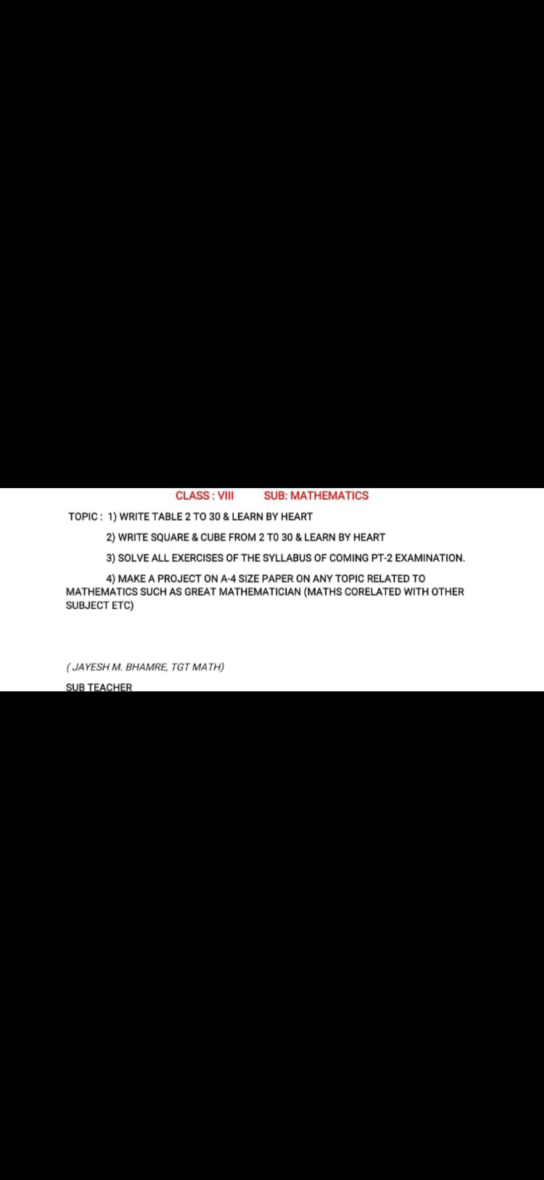

**WINTER HOLIDAY HOMEWORK 2021-22**

**CLASS: IX MATHS**

|  |
| --- |
| **ITEM 1**  **PAPER FOLDING** |
| Paper folding Activity:  Priya wants to arrange her rectangular family photograph in the middle of a rhombus shaped photo frame. To adjust the photo in the frame, she needs to find the proper size of the available rectangle and hence, she takes a paper exactly equal to the size of the frame and identifies the rectangle available in the middle of the frame by paper folding activity.    Q1. How can Priya be confirmed about the shape of the frame to be a rhombus?  Q.2. Why paper folding method is adopted by Priya?  Q3. Explain the geometrical principle underlying the activity and justify. |

**ITEM 2**

**COTTAGE INDUSTRY**

**Q1.  A small cottage industry employing people from a nearby slum area prepare round table clothes having six equal design in the six segment formed by equal chords AB, BC, CD, DE, EF and AF. If O is the centre of round table (see figure). Find** **AEB and** **AFB.**

1. **60O Both                B. 900 Both**

**C.  300 Both    D. 450 Both**

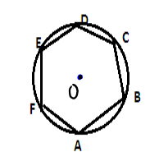

**ITEM 3**

**THE PROTEST**

**Q1. Three students Priyanka, Sania and David are protesting against killing in innocent animals for commercial purposes in a circular park of radius 20m. They are standing at equal distances on its boundary by holding banners in their hands. find the distance between them.**

**A. 20√3    B.  10√3     C.  50√3        D.  100√3**

**ITEM 4**

**SQUARE WATERMELONS**

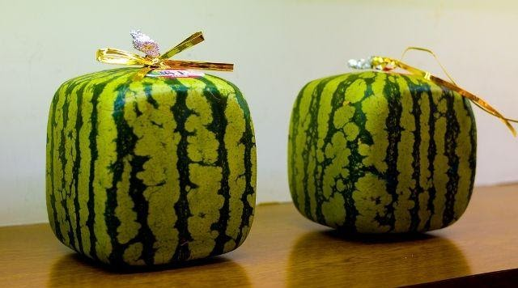

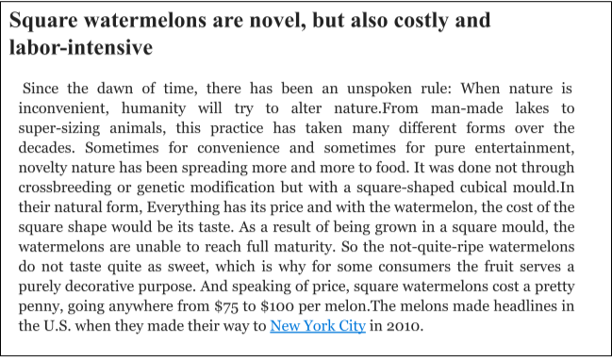

**KENDRIYA VIDYALAYA AFS, OJHAR**

**TERM -2 (HOLIDAYAS HOME WORK**)

CLASS –X (MATHS)

Math Labs with Activity – 1

Equal Chords of a Circle Subtend

**OBJECTIVE**

To verify that equal chords of a circle subtend equal angles at the centre of the circle

**Materials Required**

1. A sheet of white paper
2. A piece of cardboard
3. A sheet of tracing paper
4. A geometry box
5. A tube of glue

**Theory**  
A line segment joining any two points on a circle is called a chord of the circle. Any two equal chords of a circle subtend equal angles at the centre of the circle.  
The theorem can be proved as below.

Consider a circle with radius r and centre O and having two equal chords AB and PQ as shown in Figure .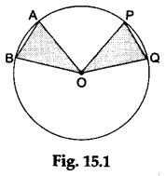

In ΔAOB and POQ, we have

1. AO=OP (each equal to r)
2. BO =OQ (each equal to r)
3. AB = PQ (equal chords)

Then, ΔAOB is congruent to ΔPOQ (by SSS-criterion).  
**∴** ∠AOB = ∠POQ.

**Procedure**  
**Step 1:** Paste the white paper on the cardboard and draw a circle with centre O on this paper.  
**Step 2:** Take a pair of compasses. Placing its needle point at a point A on the circle and taking any radius, draw an arc cutting the circle at some point B. Joining AB we get a chord of the circle.  
Taking the same radius and again placing the needle point of the compasses at another point P on the circle, draw an arc cutting the circle at some point Q. Joining PQ we get another chord which is equal to the chord AB.  
**Step 3:** Join AO and BO to form the triangle AOB. Also, join PO and QO to form the triangle POQ (see F**Step 4:** Trace the ΔAOB on the tracing paper.  
**Step 5:** Place the ΔAOB obtained on the tracing paper over the ΔPOQ such that AB overlaps PQ.igure **Observations**  
We observe that the ΔAOB completely overlaps the ΔPOQ. Therefore, the ΔAOB is congruent to the ΔPOQ.  
So, we conclude that ∠AOB = ∠POQ.

**Result**  
It is verified that equal chords of a circle subtend equal angles at the centre of the circle.

## **Math Labs with Activity – 2**

## **Chords of a Circle which are Equidistant from Centre of Circle**

**OBJECTIVE**

To verify that the chords of a circle which are equidistant from the centre of the circle are equal.

**Materials Required**

1. A sheet of transparent paper
2. A geometry box

**Procedure**  
**Step 1:** Mark a point O on the sheet of transparent paper. Draw a circle with centre O taking any radius.  
**Step 2:** Draw any chord AB in the circle. Fold the paper along the line that passes through the centre O of the circle and cuts the chord AB such that one part of the chord AB overlaps the other part.  
Make a crease and unfold the paper. Mark the point M where the line of fold cuts the chord AB. Join OM.  
Then, OM is the perpendicular bisector of the chord AB and gives the distance of the chord AB from the centre O of the circle.  
**Step 3:** Draw any radius OC. On this radius OC, mark a point N such that OM = ON.  
**Step 4:** Fold the paper along the line that passes through the point N such that NC overlaps NO. Make a crease and unfold the paper.  
Mark the points P and Q where the line of fold cuts the circle. Join PQ.  
Then, PQ is a chord of the circle whose distance from the centre O of the circle is ON, which is equal to the distance OM of the chord AB from the centre O of the circle (see Figure 25.1).  
**Step 5:** Fold the paper along the line which passes through the centre O of the circle such that OM overlaps ON.  
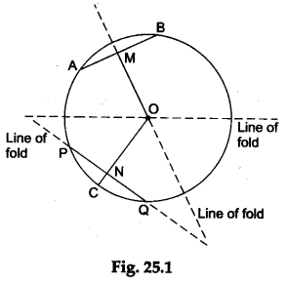

**Observations**

1. OM exactly covers ON since OM = ON.
2. AB exactly covers PQ. This shows that the chord AB is equal to the chord PQ.

**Result**  
It is verified that the chords of a circle which are equidistant from the centre of the circle are equal.

**Math Labs with Activity – 3**

**The Lengths of the Tangents Drawn from an External Point to a Circle**

**OBJECTIVE**

To verify that the lengths of the tangents drawn from an external point to a circle are equal

**Materials Required**

1. A sheet of transparent paper
2. A geometry box

**Theory**

The theorem can be proved as follows.  
Let two tangents AP and AQ be drawn from a point A (external point) to a circle with its centre at O and having a radius r.  
Join OP, OQ and OA.  
In AOPA and OQA, we have

1. OP=OQ (each is equal to r)
2. OA =OA (common)
3. ∠OPA = ∠OQA (each is equal to 90° since AP and AQ are tangents).

**∴** ΔOPA is congruent to ΔOQA (by RHS-criterion).  
Hence, AP = AQ, i.e., the two tangents are equal.  
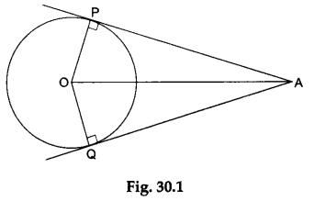

**Procedure**  
**Step 1:** Mark a point O on the sheet of transparent paper. With O as the centre, draw a circle of any radius.  
**Step 2:** Mark a point A outside the circle.  
**Step 3:** Fold the paper along the line that passes through the point A and just touches the circle. Make a crease and unfold the paper. Mark the point P where the line of fold touches the circle. Join AP. Then, AP is one of the tangents to the circle from the point A.  
**Step 4:** Fold the paper along the line that passes through the point A and just touches the circle at a point other than P. Make a crease and unfold the paper. Mark the point Q where the line of fold touches the circle. Join AQ. Then, AQ is another tangent to the circle through the point A.  
**tep 5:** Join OP, OQ and OA, as shown in Figure 30.2.  
**Step 6:** Fold the paper along the line OA.  
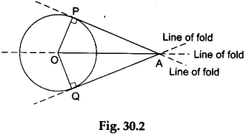**Observations**  
We observe that when the paper is folded along the line OA, the point P falls exactly on the point Q. Therefore, AP = AQ.**Result**  
It is verified that the lengths of the tangents drawn from an external point to a circle are equal.

**Math Labs with Activity –4**

**Volume of a Right-Circular Cylinder Formula**

**OBJECTIVE**

To demonstrate a method to derive a formula for finding the volume of a right-circular cylinder

**Materials Required**

1. A right-circular cylinder made of plastic clay (Plasticine)
2. A knife
3. A ruler
4. **Theory**  
   The volume of a right-circular cylinder of height h and base radius r is given by πr²h.
5. **Procedure**  
   **Step 1:** Take a right-circular cylinder made of plastic clay having height h and base radius r.  
   **Step 2:** Cut the cylinder with a sharp knife into eight parts as shown in Figure 37.1.  
   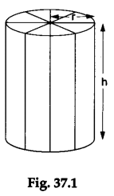

**Step 3:** Place the eight parts adjacent to each other to form a solid structure approximately resembling a cuboid as shown in Figure 37.2.  
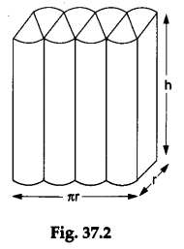

**Observations and Calculations**  
The eight parts together approximately form a cuboid having length πr, breadth r and height h.  
**∴** the volume of the cuboidal block = πr x r x h = πr²h.  
Hence, the volume of the cylinder = πr²h.

**Result**  
The volume of a right-circular cylinder of height h and base radius r is given by πr²h.

**SOLVE THE FOLLOWING QUESTIONS**

1.A contractor plans to install two slides for the children to play in a park. For the children below the age of 5 years, she prefers to have a slide whose top is at a height of 1.5 m, and is inclined at an angle of 30° to the ground, whereas for elder children, she wants to have a steep slide at a height of 3 m, and inclined at an angle of 60° to the ground. What should be the length of the slide in each case?

2.The angle of elevation of the top of a tower from a point on the ground, which is 30 m away from the foot of the tower is 30°. Find the height of the tower.

3.A 1.5 m tall boy is standing at some distance from a 30 m tall building. The angle of elevation from his eyes to the top of the building increases from 30° to 60° as he walks towards the building. Find the distance he walked towards the building.

4.From a point on the ground, the angles of elevation of the bottom and the top of a transmission tower fixed at the top of a 20 m high building are 45° and 60° respectively. Find the height of the tower.

5. A statue, 1.6 m tall, stands on the top of a pedestal. From a point on the ground, the angle of elevation of the top of the statue is 60° and from the same point the angle of elevation of the top of the pedestal is 45°. Find the height of the pedestal.

6.Prove that the tangents drawn at the ends of a diameter of a circle are parallel.

# 7. The volume and curved surface area of the cylinder are 1650 cubic cm and 660 sq. cm respectively. Find the radius and height of the cylinder.

8. 2 cubes each of volume 64 cm3 are joined end to end. Find the surface area of the resulting cuboid.  
9. A vessel is in the form of a hollow hemisphere mounted by a hollow cylinder. The diameter of the hemisphere is 14 cm and the total height of the vessel is 13 cm. Find the inner surface area of the vessel.

10. A medicine capsule is in the shape of a cylinder with two hemispheres stuck to each of its ends. The length of the entire capsule is 14 mm and the diameter of the capsule is 5 mm. Find its surface area.

.

**KENDRIYA VIDYALAYA AFS OJHAR**

**WINTER BREAK HOMEWORK**

**SUBJECT - MATHEMATICS**

**CLASS XI 2021-22**

**Q.1** **HOME ASSESSMENT IN ACTIVITY COPY (PRACTICAL NOTEBOOK**)

**Lab Manual Activites to be done in Activity Book. This is important for internal Assessment for internal marks**.

**ACTIVITY 1**

To find the number of ways in which three cards can be selected from given five cards

**ACTIVITY 2**

To construct different type of conic sections.

**ACTIVITY 3**

Verification of the geometrical significance of derivative

**Q.2 PROVE THAT**

1) 2 + + 2 = 10

2) sin2x +2sin4x + ain6x =

3) (sin3x + sinx)sinx + (cos3x - cosx)cosx = 0

4) sin3x + sin2x – sinx = 4sinx $cos\frac{x}{2}$ $cos\frac{3x}{2}$

**Q.3 Find $sin\frac{x}{2}$, $cos\frac{x}{2}$, and $tan\frac{x}{2}$ in each of the following**

1) = , x in quadrant II

2) cos = , x in quadrant III

3) = , x in quadrant II

**Q. 4 WRITE DOWN THE SUMMERY OF CHAPTER TRIGNOMETRIC FUNCTION (ALL TRIGNOMETRIC IDENTITIES) PAGE NO. 82,83 & 84**

**KENDRIYA VIDYALAYA AFS OJHAR**

**WINTER BREAK HOMEWORK**

**SUBJECT - MATHEMATICS**

**CLASS XII 2021-22**

**HOME ASSESSMENT IN ACTIVITY COPY (PRACTICAL NOTEBOOK**)

**Lab Manual Activites to be done in Activity Book. This is important for internal Assessment for internal marks**.

**ACTIVITY 1**

To verify that angle in a semicircle is a right angle, using vector method.

**ACTIVITY 2**

To locate the points of given coordinates in space, measure the distance between two points in space and then verify the distance using distance formula.

**ACTIVITY 3**

To evaluate the definite integral $\int_{a}^{b}{\sqrt{(1-x^{2})}}$ dx as the limit of a sum and verify it by actual integration.

**ACTIVITY 4**

To measure the shortest distance between two skew lines and verify it analytically.

**ACTIVITY 5**

To explain trhe computation of conditional probability of a given event A when event Bhas already occured, through an example of throwing a pair of dice.

**Q. Find the following integrals**

1) dx

2) dx

3)

4) dx

5) dx

6) dx

7) dx

8)

9) ) dx

10 ) dx

**KENDRIYA VIDYALAYA AIR FORCE STATION OJHAR**

**Class XI**

**BIOLOGY HHW-2021**

**Solve the following questions**

1. Columnar and cuboidal epithelium bearing cilia is called ciliated epithelium. Name two organs in our body where ciliated epithelium is present.
2. Write any two differences between racemose and cymose inflorescence
3. How animals are classified on the basis of nature of body cavity? Draw the sectional view of an organism having body cavity.

OR

“All vertebrates are chordates but all chordates are not vertebrates”. Justify the statement.

1. What is water potential? Study the given fig. given below in which the two chambers A and B containing solutions are separated by semipermeable membrane and answer the given questions.

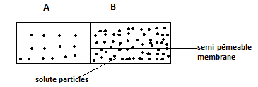

i) Solution of which chamber has a lower water potential.

ii) Solution of which chamber has a lower solute potential.

iii) In which direction will osmosis occur?

iv) At equilibrium which chamber has lower water potential?

1. a) Explain the disadvantages of two kingdom classification?

b) Write two living and two non-living features of virus.

1. a) Classify and describe the flowers on the basis of position of ovary with respect to other floral appendages.  
   b) What are (a).Pneumatophores and (b) Stilt roots. Explain their function in the respective plants.

|  |  |
| --- | --- |
|  | **Solve the following** |
| 1 | **The term cell was given by**   1. Robert Hooke 2. Tatum 3. Schwann 4. De Bar |
| 2 | **This cell organelle does not contain DNA**  (a) Nucleus  (b) Mitochondria  (c) Lysosomes  (d) Chloroplast |
| 3 | **Which of the following statements is true about cell theory?**  (a) The Cell theory does not apply to fungi  (b) The Cell theory does not apply to virus  (c) The Cell theory does not apply to algae  (d) The Cell theory does not apply to microbes |
| 4 | **_____________is the study of the cell, its types, structure, functions and its organelles.**  (a) Biology  (b) Cell Biology  (c) Microbiology  (d) Biotechnology |
| 5 | **Which of the following cell organelles is absent in prokaryotic cells?**  (a) Nucleus  (b) Lysosome  (c) Endoplasmic Reticulum  (d) All of the above |
| 6 | **In prokaryotic cells, ribosomes are**  (a) 70 S  (b) 80 S  (c) 60S + 40S  (d) 50S + 40S |
| 7 | **In prokaryotes, the hair-like outgrowths which attach to the surface of other bacterial cells are**  (a) Flagella  (b) Pili  (c) Capsule  (d) Plasmids |
| 8 | **Which structure serves as a protective layer against attack by phagocytes and by viruses?** (A) Capsule (B) Appendages (C) Mesosome (D) Mitochondria |
| 9 | **The association of more than one ribosome with a single molecule of m-RNA complex is called as**… (A) Polypeptide (B) Polysome (C) Polymer (D) Poly Saccharide |
| 10 | **Which structure possess flagellin protein?** (A) Muscles fiber (B) Flagellum (C) Pilli (D) a,b,c-all |

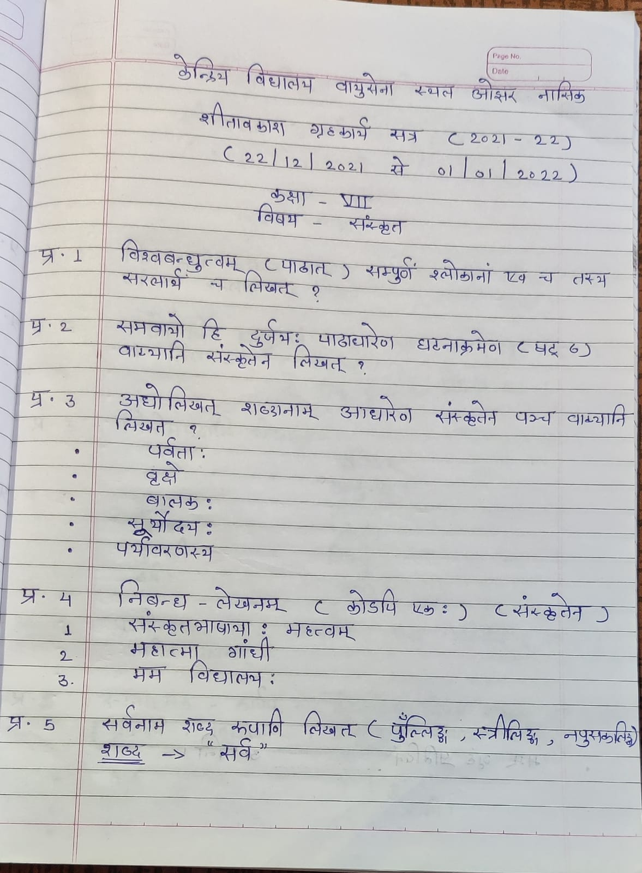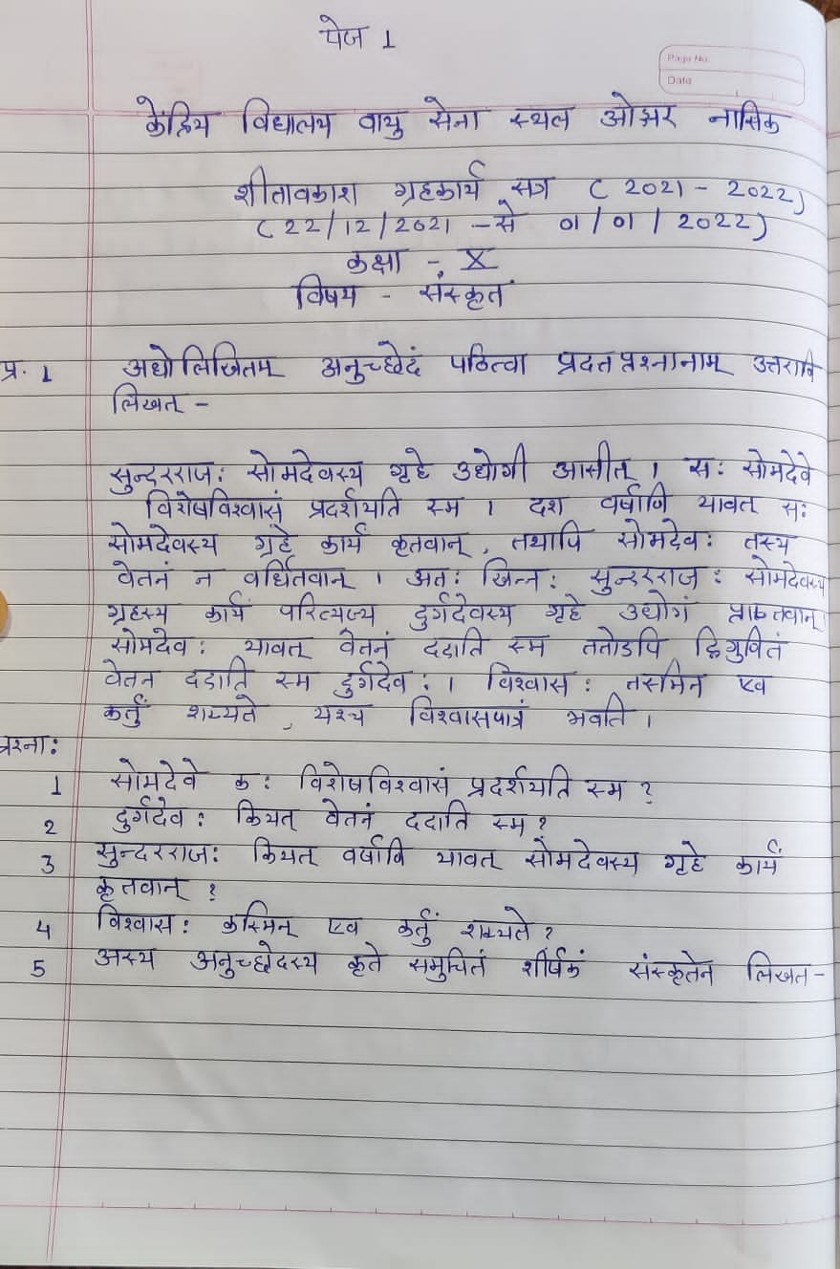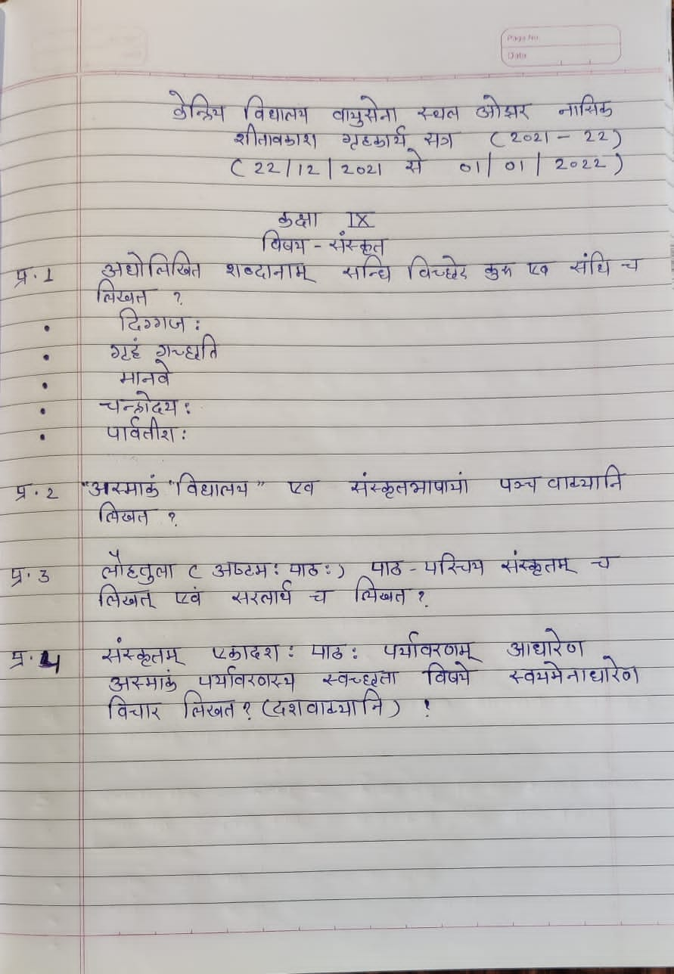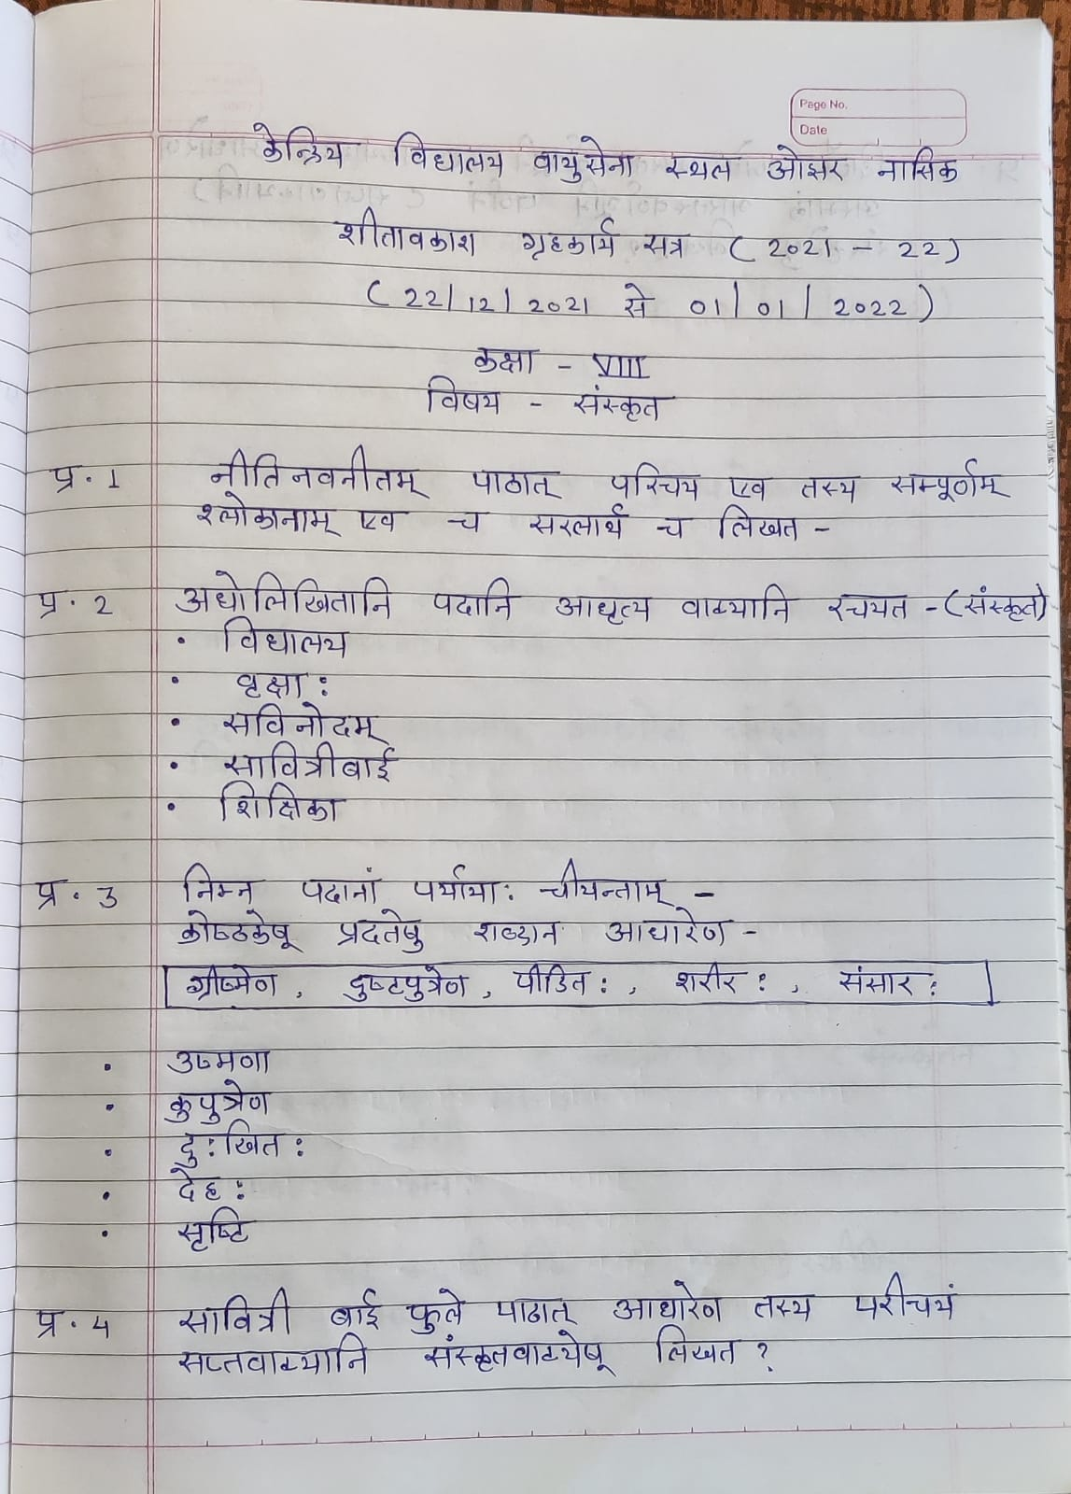

XII Economics

Holiday Homework for Winter Vacation Economics : Class 12th

Complete the notes of the Lesson :- National Income and solve 5 Numerical Questions from the National income given herewith

Although , Class notes have already been sent , yet ,once again the the same is been being sent to you.

1. Calculate the net value added at the market price of a firm:

|  |  |
| --- | --- |
| **Items** | **Amount** |
| Sale  Change in stock  Depreciation  Net indirect taxes  Purchase of machinery  Purchase of an intermediate product | 400  -20  30  40  200  250 |

1. Calculate the nominal income and private income from the following data.

|  |  |
| --- | --- |
| **Contents** | **₹. (in crores)** |
| Net current transfers from the rest of the world | 10 |
| Private final consumption expenditure | 600 |
| National debt interest | 15 |
| Net exports | -20 |
| Current transfers from the government | 5 |
| Net domestic product at factor cost accruing to the government | 25 |
| Government final consumption expenditure | 100 |
| Net indirect tax | 30 |
| Net domestic capital formation | 70 |
| Net factor income from abroad | 10 |

1. **Calculate private income, personal income, personal disposable income and** **National disposable income from the following data:**

|  |  |  |
| --- | --- | --- |
|  | | (Rs. in Crores) |
| (i) | National income | 3000 |
| (ii) | Savings of private corporate sector | 30 |
| (iii) | Corporate tax | 80 |
| (iv) | Current transfer from government | 60 |
| (v) | Income from property and entrepreneurship to government | 150 |
| (vi) | Current transfers from rest of the world | 50 |
| (vii) | Savings of non-departmental government sector | 40 |
| (Viii) | Net indirect taxes | 250 |
| (ix) | Direct taxes paid by household | 100 |
| (x) | Net factor income from abroad | (-) 10 |

4. **Calculate NI by income and expenditure method:**

|  |  |  |
| --- | --- | --- |
|  | | (Rs. in Crores) |
| (i) | Subsidies | 5 |
| (ii) | Private final consumption expenditure | 100 |
| (iii) | NFIA | (-) 10 |
| (iv) | Indirect Tax | 25 |
| (v) | Rent | 5 |
| (vi) | Government final consumption expenditure | 20 |
| (vii) | Net domestic fixed capital formation | 30 |
| (viii) | Operating surplus | 20 |
| (ix) | Wages | 50 |
| (x) | Net export | (-) 5 |
| (xi) | Addition to stock | (-) 5 |
| (xii) | Social security contribution by employers | 10 |
| (xiii) | Mixed income | 40 |

5. **Estimate the following with the help of given data:**  
**(i) GDPMP ,**  
**(ii) Net Value Added at factor cost; and (iii) prove that it is equal to the income generated.**

|  |  |  |
| --- | --- | --- |
|  | | (Rs. in Crores) |
| (i) | Increase in the stock of unsold goods | 1000 |
| (ii) | Sales | 10,000 |
| (iii) | Net indirect tax | 800 |
| (iv) | Purchase of raw materials from other firms | 1650 |
| (v) | Purchase of fuel and power | 850 |
| (vi) | Consumption of fixed capital | 500 |
| (vii) | Rent | 700 |
| (viii) | Wages and salaries | 3500 |
| (ix) | Interest payment | 1000 |
| (x) | Dividend | 1500 |
| (xi) | Corporate gain tax | 300 |
| (xii) | Undistributed profit | 200 |

**Economics: Class 11th**

Holiday Homework for Winter Vacation Economics : Class 11th Complete the notes of the Lessons :- Microeconomics 1.Production Function and Return to a Factor

2.Concept of Cost.

Statistics :-

Measures of Dispersion

Solve 3 Numerical Questions from the Standard Deviation and 2 numerical questions from Coefficient of Correlation .

Although , Class notes have already been sent , yet ,once again the the same is been being sent to you.

**KENDRIYA VIDYALAYA AIR FORCE STATION OJHAR**

**WINTER BREAK HOLIDAYS HOME WORK 2021-22**

**CLASS XI: BUSINESS STUDIES (054)**

TERM 2:

**CH.8 Sources of Business Finance**

**QUICK REVISION**

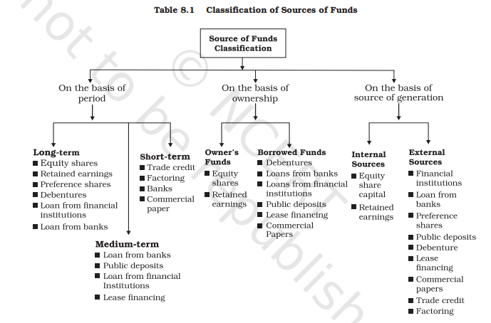

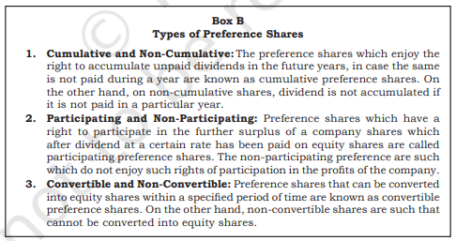

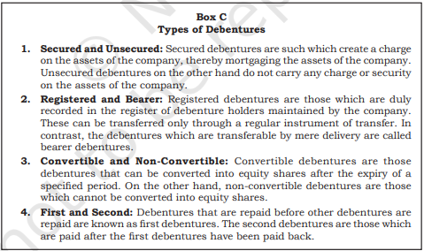

**Long Answer Questions**

1. Explain trade credit and bank credit as sources of short-term finance for business enterprises.

2. Discuss the sources from which a large industrial enterprise can raise capital for financing modernisation and expansion.

3. What advantages does issue of debentures provide over the issue of equity shares?

4. State the merits and demerits of public deposits and retained earnings as methods of business finance.

5. Discuss the financial instruments used in international financing.

**Projects/Assignment**

1.On the basis of the sources discussed in the chapter, suggest suitable options to solve the financial problem of the restaurant owner.

2. Prepare a comparative chart of all the sources of finance

**CH. 9 MSME AND BUSINESS ENTREPRENEURSHIP**

**QUICK REVISION**

Small scale industries contribute significantly to the development process and acts as a vital link in industrialization in terms of production, employment and exports for economic prosperity by widening the entrepreneurial base and use of local raw materials and indigenous skills.

**Types of Small Business**

Business enterprises are classified as Manufacturing Enterprises, Service Enterprises, Village Industries and Cottage Industries. Among these manufacturing and service enterprises are again subdivided into Micro, Small and Medium Enterprises. The definition used by the Government of India to describe small industries is based on the investment in plant and machinery. The Micro, Small and Medium Enterprises Development (MSMED) Act 2006 has been passed by the Government of India to address the issues of small enterprises

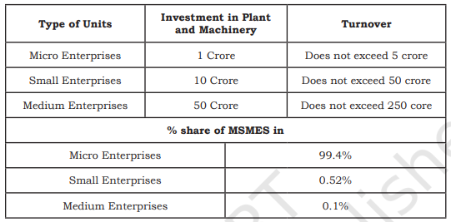

SOURCE: NCERT

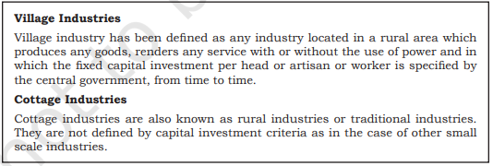

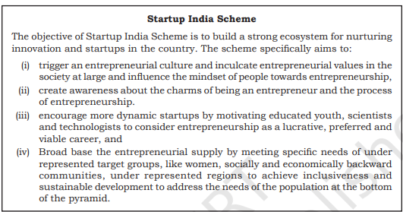

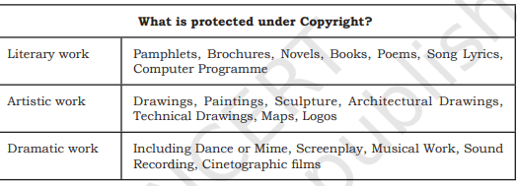

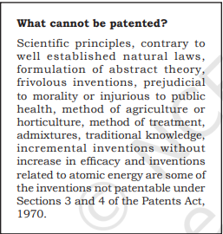

**Role of Small Business in Rural India**

Small business organizations play an important role in the socio economic development of the country. Some of them are as follows:

a. Multiple sources of income for family.

b. Self employment opportunities in commerce, manufacturing and service segments.

c. Promotion of agro based rural industries.

d. Employment opportunities for artisans and the weaker sections of society.

e. Migration of rural people to urban areas in search of employment has been stopped.

f. Helped to solve the problem of poverty and unemployment.

g. Helped to reduce the income inequalities up to a certain extent.

h. Accelerated industrial growth of the country.

Government Assistance to Small Industries and Small Business Units

Government provides various support measures and programs for the promotion of small and rural Industries, some of them are given below:

**National Bank for Agriculture and Rural Development (NABARD)**

1. • Set up in 1982 for integrated rural development.
2. • Provides finance to small industries, cottage and village industries and artisans.
3. • Offers counseling and consultancy services.
4. • Training and development programs for rural entrepreneurs

**National Small Industries Corporation (NSIC)**

• Set up in the year 1955 to promote and foster the growth of SSIs in India.

• Supply of indigenous and imported machines on hire purchase basis.

• Supply of raw materials – locally and imported.

• Support in export of products. • Monitoring and advisory services.

• Providing latest technology.

• Awareness on technological upgradation.

• Development of software technology parks and technology transfer centres..

**District Industries Centres (DICs)**

• Established in 1978

• To support small entrepreneurs at district level.

• Provides all facilities and support to set up small and village industries.

• Identification of suitable schemes for entrepreneurs by Central and State Govts.

• Preparation of feasibility reports on each industry.

• Arrangement of credit facilities and Equipments.

. • Arrangement of raw materials.

• To impart training for artisans, entrepreneurs etc

**Entrepreneurship Development**

The word entrepreneur is derived from the French verb entreprende, which means to undertake. Entrepreneurship is the process of setting up of one’s own business. The person who sets up the business is entrepreneur and the outcome of the process (business unit) is called enterprise.

“Entrepreneur is a person who organizes the business, undertakes the risk and enjoys the profit” – Richard Cantillon_French Economist.

An entrepreneur is basically a businessman and he brings together the factors of production such as land, labour and capital and organizes it. An entrepreneur is more than a businessman, if a businessman brings some innovation to his activities and eyes on value addition to his products or services, he is called an entrepreneur. In fact, all entrepreneurs are businessmen, but all businessmen are not entrepreneurs.

“**Entrepreneurship** is the purposeful activity of an individual or a group of associated individuals, undertaken to initiate, maintain or organize profit oriented business unit for production or distribution of economic goods and services.

**Start up India Scheme**

Start up India Scheme is an important initiative by Govt. of India to promote a strong ecosystem for nurturing innovation and start up (new enterprises) in the country.

Ways to fund start up

**1. Boot Strapping** – Self financing by the promoters from their personal savings and resources. **2. Crowd Funding** – Pooling resources by a group of people for a common goal especially through internet platforms.

**3. Angel Investment** – Angel investors are the individuals with surplus cash who have keen interest to invest in Start ups. They also offer mentoring or advice along with capital.

**4. Venture Capital –** Venture capitalists provide professionally managed funds to companies and start ups that have huge potential. It is also called risk capital as it is invested in new ventures. Eg: Accel Partners, Blume Ventures etc.

**5. Business Incubators and Accelerators** – Incubators provide funds for Start ups in the early stage of its business, whereas accelerators help the Start ups to run or to take a giant leap in business. Eg: Angel Prime, Khosla Labs, Start up Village etc.

6**. Microfinance and NBFCs** – Microfinance is a category of financial services targeted at individuals and small business who lack access to conventional banking or who have not qualified for a bank loan. Eg: BSS Microfinance P Ltd. , Asirvad Microfinance Pvt. Ltd. etc.

**NBFCs**

**(Non Banking Financial Companies)** are registered under Indian Companies Act and they perform only lending functions to public and they cannot accept demand deposits such as SB A/c, Current A/c etc. Eg: Mahindra & Mahindra Financial Services Ltd., Muthoot Finance Ltd., Bajaj Finance Ltd. etc.

**Very Short Answer Questions**

1. Which year the MSMED Act passed?

2. What is the micro enterprise.

3. What is a cottage industry?

4. What is meant by Village and Khadi Industry?

5. Give any two characteristics of entrepreneurship development.

**Short Answer Questions**

1. What is MSME?

2. State the meaning of entrepreneurship?

3. MSME and Entrepreneurship are connected. Do you agree. Give two reasons.

4. State the role of MSME in development of a country?

5. What are the different parameters used to measure the size of MSME?

6. State the meaning of Village and Khadi industries?

7. State any three major problems faced by MSMEs?

**Long Answer Questions**

1. How do small scale industries contribute to the socio-economic development of India? Discuss

2. Describe the role of small business in rural India.

3. Discuss the problems faced by small scale industries.

4. What measures has the government taken to solve the problem of finance and marketing in the small scale sector?

5. ‘Innovation is integral to MSME’. Discuss giving reasons to your answer.

6. ‘Creativity and Innovation is the key to MSME’. Justify the statement.

…………………………………………………………….***********………………………………………………………………………..

**Class 10th Science**

Q1.

(a) What are hydrocarbons? Give examples.

(b) Give the structural differences between saturated and unsaturated hydrocarbons with two examples each.

(c) What is a functional group? Give examples of four different functional groups.

2. Draw the electron dot structure of ethyne and also draw its structural formula

3. Identify and name the functional groups present in the following compounds.

(a)CH3CH2OH

(b) CH3CH2CH2COOH

(c) HCHO

(d)CH3COCH3

4. In electron dot structure, the valence shell electrons are represented by crosses or dots.

(a) The atomic number of chlorine is 17. Write its electronic configuration

(b) Draw the electron dot structure of chlorine molecule.

5. Catenation is the ability of an atom to form bonds with other atoms of the same element. It is exhibited by both carbon and silicon. Compare the ability of catenation of the two elements. Give reasons.

6. Which of the following statements are usually correct for carbon compounds? These

1. are good conductors of electricity
2. are poor conductors of electricity
3. have strong forces of attraction between their molecules
4. do not have strong forces of attraction between their molecules

(a) (i) and (iii)

(b) (ii) and (iii)

(c) (i) and (iv)

(d) (ii) and (iv)

**KENDRIYA VIDYALAYA AFS OJHAR**

**CLASS XI**

**WINTER BREAK HHW 2021-22**

Q1. State and prove theorem of parallel axes.

Q2. State and prove theorem of perpendicular axes.

Q3. Derive an expression for momentum conservation and center of mass motion

Q4. Derive the relation between torque and angular momentum.

Q5. What do you mean by moment of inertia? Write the unit and dimension of moment of inertia.

Q6. Explain the physical significance of radius of gyration.

Q7. Derive the relation between angular momentum and moment of inertia.

Q8. What is escape velocity ? Derive an expression. For it .

Q9. What do you by mean by gravitational potential energy ? Derive an expression for it.

Q10. Explain the behaviour of a stretched wire under increasing load.

Q11. State and prove stokes Law ?

Q12. What do you mean by terminal velocity ? Derive an expression for it.

**Class VII**

**SCIENCE HHW-2021**

1**) Define the Following Terms-**

**A) BLOOD VESSELS E) REPRODUCTION**

**B) EXCRETION F) POLLINATION**

**C) BLOOD G) DISPERSAL OF SEEDS**

**D) XYLEM H) SPEED**

**2) Draw the labelled diagram of-**

**a) Human Excretory System**

**b) Human Heart**

**3) Distinguish between**

**(a) Self-Pollination and Cross Pollination**

**(b) Asexual and Sexual Reproduction**

**4) Draw the diagrams of reproductive parts of flower.**

**5) Define speed.**

**6) Solve the following numerical**

1. **A train travels a distance of 300km/hr. with an average speed of 60km/hr. How much time does it take to cover the distance?**
2. **Anil & Alex are car drivers. Anil drove 180km in 4 hrs. & Alex drove 230 km in 5 hrs. whose average speed is greater?**

**7) Note on Asexual Reproduction**

**Winter Break Holiday Homework**

Subject: Science Class: VIII B

**Q.1 Activity:**

Preparea tester to test conduction based on magnetic effect of the electricity.

**Q.2 Sketch larynx and explain its function in your own wordsand sketch diagram of human eye and explain its mechanism**.

**Q.3solve the following Question.**

1) Why it is dangerous to touch electrical appliances with wet hands?

2) Does distilled water conduct electricity?

3) Why it is difficult to move on a wet marble floor?

4) Do all animals produce sound by vocal chord

5) Why the sound of baby is feeble?

6) Explain that sound travel in liquid as well.

7) How does Shrillness or pitch is affected by frequency?

8) what is oscillatory motion? Give its examples

9)write note on some harms of friction.

10)what do you mean by magnetic effect of electricity.?

11)what are insulator and conductor?

12)what is drag?

13)what is sliding friction?

14) why do we shape aeroplane like a bird?

15)Name some substances which make the liquids good conductor of electricity

**KENDRIYA VIDYALAYA AFS OJHAR**

**CLASS VI**

**WINTER BREAK HHW 2021-22**

**Q1. Arrange the following lengths on their increasing magnitude.**

**1 meter , 1 centimeter , 1 kilometer , 1 millimeter**

**Q2. The height of a person is 1.65m. Express it in cm and mm.**

**Q3. Write the similarities and differences between the motion of a bicycle and a ceiling fan that has been switched on.**

**Q4. Give two examples of periodic motion.**

**Q5. In a completely dark room if you hold up a mirror in front of you, will you see a reflection of your self in the mirror ?**

**Q6. How will you prove that light travels in a straight line ?**

**Q7. Why should an electrician use rubber gloves while repairing an electric switch at your home ? Explain.**

**Q8. The handles of the tools like screwdriver and plyer used by the electrician for repair work usually have plastic or rubber covers on them ? CAN you explain why ?**

**Q9. Write any two properties of a magnet.**

**Q10. You are given an iron strip. How will you make it into a magnet ?**

**Q11. How is a compass used to find direction ?**

**Q12. Draw a neat and labeled diagram of water cycle.**

**Q13. How are clouds formed ?**

**Q14. When does a drought occur ?**

**Class VII**

**SCIENCE HHW-2021**

1**) Define the Following Terms-**

**A) BLOOD VESSELS E) REPRODUCTION**

**B) EXCRETION F) POLLINATION**

**C) BLOOD G) DISPERSAL OF SEEDS**

**D) XYLEM H) SPEED**

**2) Draw the labelled diagram of-**

**a) Human Excretory System**

**b) Human Heart**

**3) Distinguish between**

**(a) Self-Pollination and Cross Pollination**

**(b) Asexual and Sexual Reproduction**

**4) Draw the diagrams of reproductive parts of flower.**

**5) Define speed.**

**6) Solve the following numerical**

1. **A train travels a distance of 300km/hr. with an average speed of 60km/hr. How much time does it take to cover the distance?**
2. **Anil & Alex are car drivers. Anil drove 180km in 4 hrs. & Alex drove 230 km in 5 hrs. whose average speed is greater?**

**7) Note on Asexual Reproduction**

**Winter Break Holiday Homework**

Subject: Science Class: VIII B

**Q.1 Activity:**

Preparea tester to test conduction based on magnetic effect of the electricity.

**Q.2 Sketch larynx and explain its function in your own wordsand sketch diagram of human eye and explain its mechanism**.

**Q.3solve the following Question.**

1) Why it is dangerous to touch electrical appliances with wet hands?

2) Does distilled water conduct electricity?

3) Why it is difficult to move on a wet marble floor?

4) Do all animals produce sound by vocal chord

5) Why the sound of baby is feeble?

6) Explain that sound travel in liquid as well.

7) How does Shrillness or pitch is affected by frequency?

8) what is oscillatory motion? Give its examples

9)write note on some harms of friction.

10)what do you mean by magnetic effect of electricity.?

11)what are insulator and conductor?

12)what is drag?

13)what is sliding friction?

14) why do we shape aeroplane like a bird?

15)Name some substances which make the liquids good conductor of electricity

**HOLIDAY’S HOMEWORK (WINTER BREAK 2021-22) CLASS: IX SUBJECT: SCIENCE CCT BASED**

**CHAPTER: 9 FORCE AND LAW’S OF MOTION**

# (I)

A boy throws a ball on a wall with different velocities and the ball bounces back in 0.1 second as shown in the figure. Observe the pictures carefully and answer questions below.

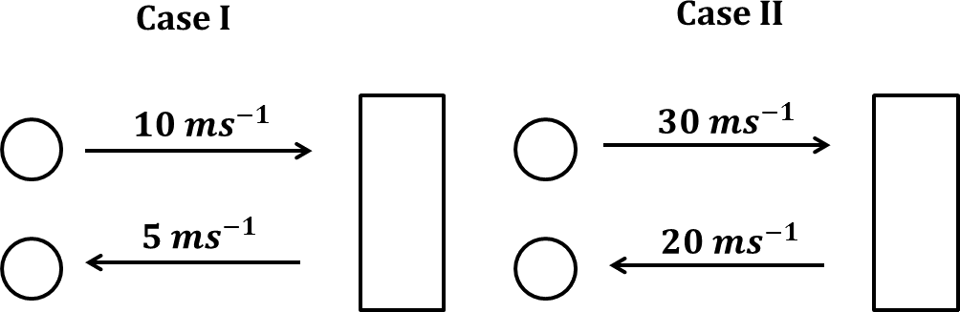

* 1. if the same ball is used in both the cases, in which case the force exerted by the wall on the ball would be greater? Justify your answer with relevant explanation.
  2. in the above case, the ball after bouncing back came to rest until the boy kicks it. This property of the ball is called

a) Inertia of rest b) inertia of motion c) inertia of direction d) None

* 1. Write Yes/No to the statements given below:

|  |  |
| --- | --- |
| a) Acceleration produced in case I is greater than Case II | Yes/No |

|  |  |
| --- | --- |
| b) Momentum in Case I is smaller than in Case II | Yes/No |

* 1. If a clay ball of mass 1 kg is used in the above given example, what happens to its final velocity and change in momentum? Use your problem solving skill to calculate in Case I.

# (II)

Sandhya playing with two spring balances at home. She heard doorbell rings! When she had opened the door, her father came early from the office, and her mother was not at home. She ran to bring a glass of water for her father. She filled it up to the brim and spilled some water while coming from kitchen to the room. She then mopped the floor so that no one slipped on it.

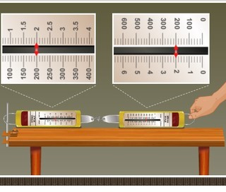

Look at the figure above and answer the following:

(11.1) When a force is applied through the free end of the spring balance A, the reading on

the spring balance A is 200 g wt. Why “the reading on spring balance B” is also 200g wt.

(11.2) Name the force which balance A exerts on balance B and the force of balance B on balance A.

(11.3) Name the law on which, this can be an example.

(11.4) Why did water spill while Sandhya was bringing it?

(11.5) What should have been done to avoid spilling of water?

(11.6) How can we slip on wet floor easily?

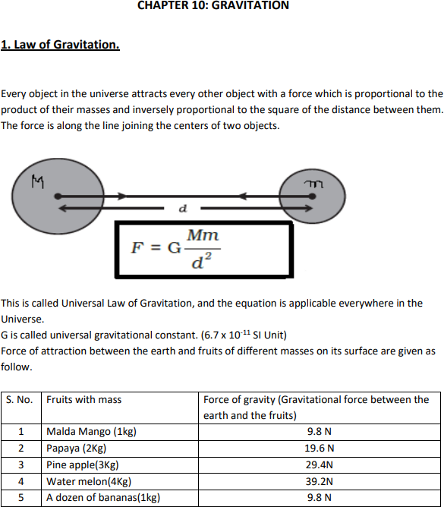

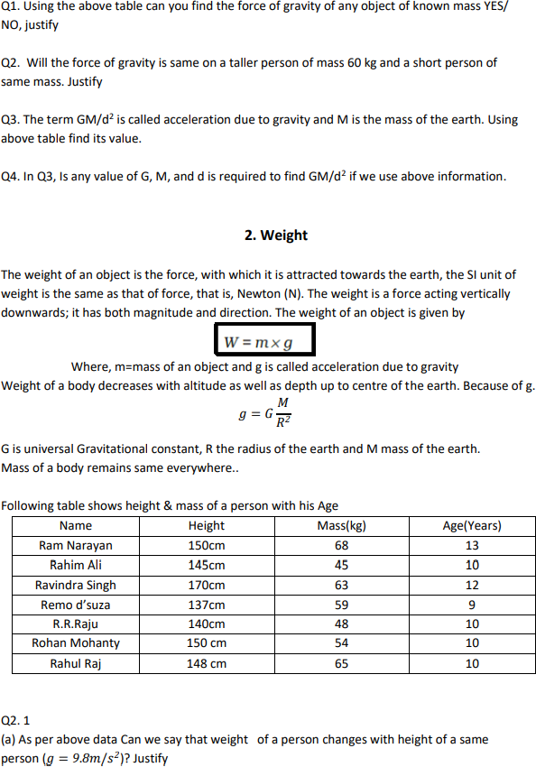

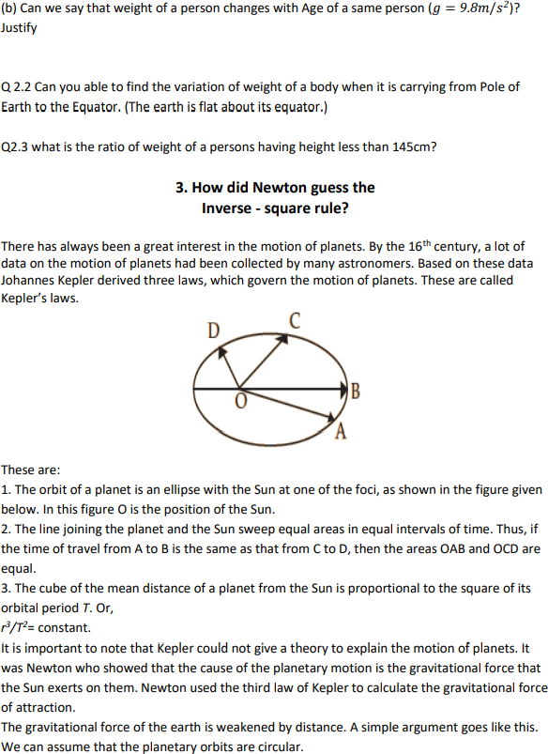

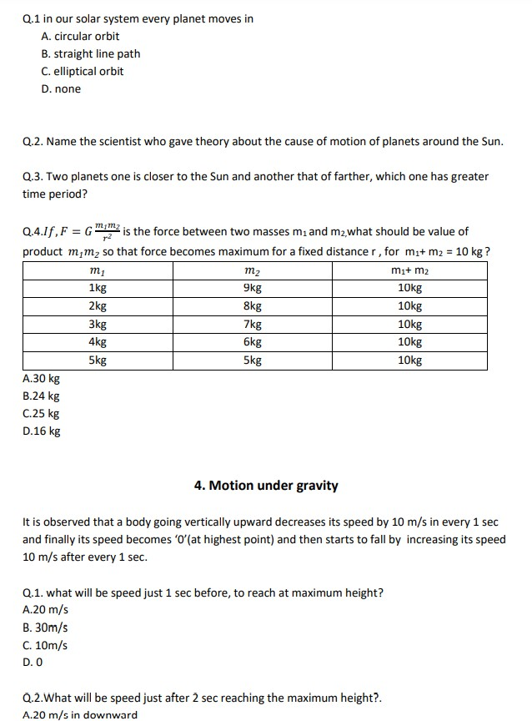

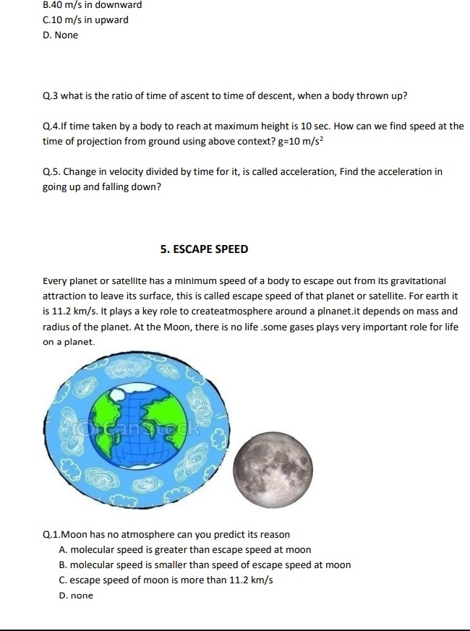

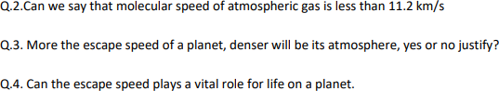

**KENDRIYA VIDYALAYA AIR FORCE STATION OJHAR**

**CLASS X HHW-2021**

Q1.

(a) What are hydrocarbons? Give examples.

(b) Give the structural differences between saturated and unsaturated hydrocarbons with two examples each.

(c) What is a functional group? Give examples of four different functional groups.

2. Draw the electron dot structure of ethyne and also draw its structural formula

3. Identify and name the functional groups present in the following compounds.

(a)CH3CH2OH

(b) CH3CH2CH2COOH

(c) HCHO

(d)CH3COCH3

4. In electron dot structure, the valence shell electrons are represented by crosses or dots.

(a) The atomic number of chlorine is 17. Write its electronic configuration

(b) Draw the electron dot structure of chlorine molecule.

5. Catenation is the ability of an atom to form bonds with other atoms of the same element. It is exhibited by both carbon and silicon. Compare the ability of catenation of the two elements. Give reasons.

6. Which of the following statements are usually correct for carbon compounds? These

1. are good conductors of electricity
2. are poor conductors of electricity
3. have strong forces of attraction between their molecules
4. do not have strong forces of attraction between their molecules

(a) (i) and (iii)

(b) (ii) and (iii)

(c) (i) and (iv)

(d) (ii) and (iv)

**KENDRIYA VIDYALAYA AFS OJHAR**

**CLASS XI**

**WINTER BREAK HHW 2021-22**

Q1. State and prove pascal' law

Q2. Explain the hydraulic brake and hydraulic lift with necessary diagram.

Q3 Define surface tension and obtain the expression for capillary rise in capillary tube.

Q4. Derive the relation for young 'modulus with necessary diagram

Q5. What is Newton' formula for viscosity.

Q6. What is velocity profile and draw it for viscous and non viscous fluid.

Q7. Define Young'modulus and bulk modulus.

Q8.

State and Piseuille' s formula and prove it using dimensions.

Q9 State and prove Bernoulli' therorem.

Q10. Explain the behaviour of a stretched wire under increasing load.

Q11. State and prove stokes Law ?

Q12. What do you mean by terminal velocity ? Derive an expression for it.

**KENDRIYA VIDYALAYA AFS OJHAR**

**HOLIDAY HOMEWORK (Winter Break 2020)**

**CLASS XII ( PHYSICS** )

ANSWERS

**Very Short Answer Type**

1 Name the part of the electromagnetic spectrum of wavelength 10-2 m and mention its one application.

2 Write the following radiations in ascending order in respect of their frequencies ;  
X-rays, Microwaves, UV rays and radiowaves.

3 Name the part of electromagnetic spectrum which is suitable for i) radar systems used in aircraft navigation

ii)treatment of cancer tumours.

4 Name the EM waves used for studying crystal structure of solids. What is its frequency range?

5 Which of the following has the shortest wavelength :  
Microwaves, Ultraviolet rays, X-rays

6 Name the physical quantity which remains same for microwaves of wavelength 1 mm and UV radiations of 1600 Å in vacuum.

7 What are the directions of electric and magnetic field vectors relative to each other and relative to the direction of propagation of electromagnetic waves?

8 Write the relationship between angle of incidence i, angle of prism A and angle of minimum deviations from a triangular

9 How does focal length of a lens change when red light incident on it is replaced by violet light? Give reason for your answer

10 A biconvex lens made of a transparent material of refractive index 1.25 is immersed in a water of refractive index 1.33. Will the lens behave as a converging or a diverging lens? Give reason

11 A biconvex lens made of a transparent material of refractive index 1.5 is immersed in a water of refractive index 1.33. Will the lens behave as a converging or a diverging lens? Give reason.

12 How are radio waves produced?  
13 Under what condition, does a biconvex lens of glass having a certain refractive index act as a plane glass sheet when immersed in a liquid

14 State the criteria for the phenomenon of total internal reflection of light to take place

15 .A converging lens axially in contact with a diverging lens; both the lenses being of equal focal lengths. What is the focal length of the combination?

16 A glass lens of refractive index 1.45 disappears when immersed in a liquid  What is the . value of refractive index of the liquid?

17 Two thin lenses of power + 6 D and -2D are in contact. What is the focal length of the combination?

18 How does the power of convex lens vary if the incident red light is replaced by violet light?

19.Define the term ‘coherent sources’ which are required to produce interference pattern in Young’s double slit experiment.

20.How does the fringe width of interference fringes change, when the whole apparatus of Young’s experiment is kept in a liquid of refractive index, 1.3?

21 **How does the angular separation of interference fringes change, in Young’s experiment, if the distance between the slits is increased?**

**Short Answer Type SA**

1 How does a charge q oscillating at certain frequency produce electromagnetic waves? Sketch a schematic diagram depicting electric and magnetic fields for an electromagnetic wave propagating along the Z-direction

2 The oscillating electric field of an electromagnetic wave is given by :  
E = 30 sin [2 × 1011 t + 300 π x] Vm-1  
(a) Obtain the value of the wavelength of the electromagnetic wave.  
(b) Write down the expression for the oscillating magnetic field

3 Draw a ray diagram of a reflecting type telescope. State two advantages of this telescope over a refracting telescope.

 4 Draw a ray diagram for the formation of image by a compound microscope. Write the expression for total magnification when the image is formed at infinity

5 A convex lens of focal length 25 cm is placed coaxially in contact with a concave lens of focal length 20 cm. Determine the power of the combination. Will the system be converging or diverging in nature?

6An astronomical telescope uses two lenses of powers 10 D and ID. What is its magnifying power in normal adjustment?

7. In Young’s double slit experiment ,plot a graph of the intensity distribution versus path difference in this experiment. Compare this with the intensity distribution of fringes due to diffraction at a single slit. What important difference do you observe?

8.(i) Use Huygens’ geometrical construction to show the behaviour of a plane wave front,   
(a)passing through a biconvex lens  
(b)reflected by a concave mirror

(c) prism

9State Huygens’ principle. Using. this principle explain the Huygen’s construction

10 .(i)What is the effect on the interference fringes to a Young’s double slit experiment when  
(a)the separation between the two slits is decreased?  
(b)the width of the source-slit is increased?  
(c)the monochromatic source is replaced by a source of white light? Justify your answer in each case

11 **How will the interference pattern in Young’s double slit experiment get affected, when**  
**(i)distance between the slits S1 and S2 reduced and**  
**(ii)the entire set up is immersed in water? Justify your answer in each case**

**12 The objective of an astronomical telescope has a diameter of 150 mm and a focal length of 4.00 m. The eyepiece has a focal length of 25.00 mm. Calculate the magnifying of telescope.**

**Long answer questions**

1.Describe Young’s double slit experiment to produce interference pattern due to a monochromatic source of light. Deduce the expression for the fringe width.

2 In Young’s double slit experiment, the two slits 0.15 mm apart are illuminated by monochromatic light of wavelength 450 nm. The screen is 1 m away from the slits.  
(i)Find the distance of the second bright fringe and dark fringe from the central maximum

(ii)How will the fringe pattern change if the screen is moved away from the slits?

3 Find the resultant intensity at a point due to superposition of two interfering waves due to superposition. Hence obtain the condition of constructive and destructive interference.

4 Define a wavefront. Use Huygens’ geometrical construction to show the propagation of plane wave front from a rarer medium (1) to a denser medium (2) undergoing refraction, hence derive Snell’s law of refraction.

5 Draw a labelled ray diagram of an astronomical telescope in the near point position. Write the expression for its magnifying power.

CLASS XI CHEMISTRY

HHW SESSION -2021-22 TYPE-1

1. Which of the following is the correct IUPAC name?
   1. 3-Ethy l– 4,4 - dimethylheptane
   2. 4,4-Dimethyl-3-ethylheptane
   3. 5-Ethyl-4,4-dimethylheptane
   4. 4,4-Bis(methyl)-3-ethylheptane
2. Electronegativity of carbon atoms depends upon their state of hybridisation. In which of the following compounds, the carbon marked with asterisk is most electronegative?
   1. CH3 – CH2 – *CH3 –CH3
   2. CH3 – *CH = CH – CH3
   3. CH3 – CH2 – C ≡ *CH
   4. CH3 – CH2 – CH = *CH2
3. In which of the following, functional group isomerism is not possible?
   1. Alcohols
   2. Aldehydes
   3. Alkyl halides
   4. Cyanides
4. 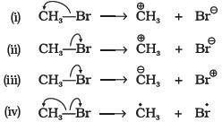Covalent bond can undergo fission in two different ways. The correct representation involving a heterolytic fission of CH3 —Br is
5. What is the correct order of decreasing stability of the following cations.

Organic Chemistry

1. II > I > III
2. II > III > I
3. III > I > II
4. I > II > III
5. The best method for separation of naphthalene and benzoic acid from their mixture is:
6. Chromatography
7. Crystallisation
8. Distillation
9. Sublimation
10. In estimation of halogens, halogen react with to form .
11. Water, Hydrochloric acid
12. Silver nitrate, Silver halide
13. Base, salt and Water
14. None of the above
15. Lassaigne’s test is used to detect:
16. Nitrogen
17. Sulphur
18. Chlorine
19. All of these
20. Greater the alkyl groups, will be hyperconjugation.
21. Larger
22. Smaller
23. Constant
24. None of the above
25. Terms m and m1 in given formula are used for ?

Percentage of sulphur = (32 × m1× 100)/233 × m

1. Number of moles of organic compound and barium sulphate
2. Mass of barium sulphate and Mass of organic compound
3. Mass of organic compound and mass of Barium sulphate
4. Number of moles of Barium sulphate and organic compound
5. In this question two or more options is correct.

Which of the following compounds contain all the carbon atoms in the same hybridization state?

1. H—C≡C—C ≡C—H
2. CH3—C ≡C—CH3
3. CH2 = C = CH2
4. CH2 = CH—CH = CH2

# TYPE-2

**Assertion and Reason Type Questions**

# In the following questions a statement of Assertion (A) followed by a statement of Reason (R) is given. Choose the correct option out of the choices given below each question.

1. Assertion (A): Simple distillation can help in separating a mixture of propan-1-ol (boiling point 97°C) and propanone (boiling point 56°C).

Reason (R): Liquids with a difference of more than 20°C in their boiling points can be separated by simple distillation.

1. Both A and R are correct and R is the correct explanation of A.
2. Both A and R are correct but R is not the correct explanation of A.
3. Both A and R are not correct.
4. A is not correct but R is correct.
5. Assertion (A): Components of a mixture of red and blue inks can be separated by distributing the components between stationary and mobile phases in paper chromatography.

Reason (R) : The coloured components of inks migrate at different rates because paper selectively retains different components according to the difference in their partition between the two phases.

1. Both A and R are correct and R is the correct explanation of A.
2. Both A and R are correct but R is not the correct explanation of A.
3. Both A and R are not correct.
4. A is not correct but R is correct.
5. Assertion (A): Pent- 1- ene and pent- 2- ene are position isomers.

Reason (R): Position isomers differ in the position of functional group or substituent.

1. Both A and R are correct and R is the correct explanation of A.
2. Both A and R are correct but R is not the correct explanation of A.
3. Both A and R are not correct. (iv) A is not correct but R is correct.
4. Assertion (A): All the carbon atoms in H2C=C=CH2 are sp2 hybridized

Reason (R): In this molecule, all the carbon atoms are attached to each other by double bonds.

1. Both A and R are correct and R is the correct explanation of A.
2. Both A and R are correct but R is not the correct explanation of A.
3. Both A and R are not correct.
4. A is not correct but R is correct.

# TYPE-3

**MATCH THE FOLLOWING**

1. Match the terms mentioned in Column I with the terms in Column II.

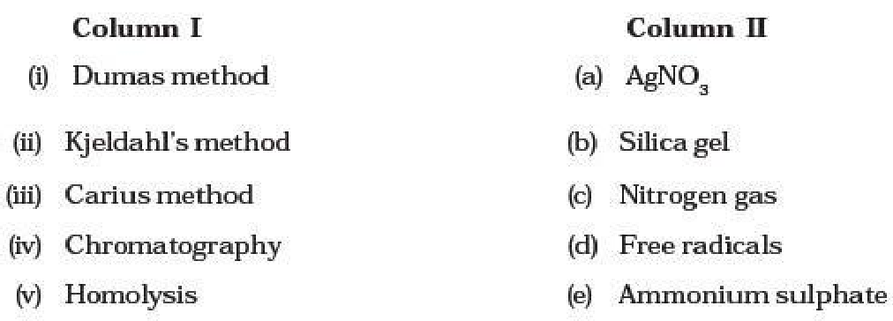

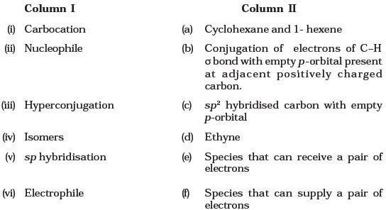

1. Match the intermediates given in Column I with their probable structure in Column II.

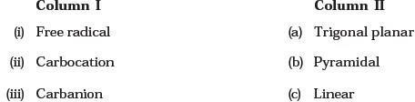

|  |  |
| --- | --- |
| Column I | Column II |
| (i) Two solids which have different solubility’s in a solvent and which do not undergo reaction when  dissolved in it. | (a) Steam distillation |
| (ii) Liquid that decomposes at its boiling point | (b) Fractional distillation |
| (iii) Steam volatile liquid | (c) Simple distillation |
| (iv) Two liquids which have boiling points close to each other | (d)Distillation  under reduced pressure |
| (v) Two liquids with large difference in boiling points | (e) Crystallization |

**CLASS XII**

**SUBJECT CHEMISTRY HHW-2021**

1. **PREPARE AN INVESTOGATORY PROJECT ON ANY TOPIC GIVEN BY CBSE INCLUDING THESE OUTLINES.**
2. **Statement of problem**
3. **Objectives**
4. **Introduction**
5. **Problem question**
6. **Method/procedure**
7. **Observations**
8. **Analysis of data**
9. **Conclusion**
10. **limitations**
11. **SAMPLE IN PDF IS SHARED IN YOUR CHEMISTRY WHATSAPP GROUP.**
12. **SOLVE THIS MCQ FOR TERM 2 SYLLABUS .CHAPTER ELECTROCHEMISTRY.**

|  |
| --- |
| Electrolytic conduction is due to the movement of:  (a) Electrons (b) Ions (c) Atoms (d) Electrons as well as ions |
| Molten NaCl conducts electricity due to presence of:  (a) Free electrons (b) Free ions (c) Free molecules (d) Atoms of sodium & chlorine |
| Pure water does not conduct electricity because it:  (a) is neutral (b) is readily decomposed  (c) is almost totally unionized (d) has a low boiling point. |
| The relation among conductance (G), specific conductance (k) and cell constant (l/A) is:  (a) $G=k\frac{l}{A}$ (b) $G=k\frac{A}{l}$ (c) $Gk=\frac{l}{A}$ (d) $G=kAl$ |
| If x is specific resistance (in S-1cm) of the electrolyte solution and y is the molarity of the solution, then (in S cm2mol-1) is given by:  (a) $\frac{1000x}{y}$ (b) $1000\frac{y}{x}$ (c) $\frac{1000}{xy}$ (d) $\frac{xy}{1000}$ |
| Equivalent conductance can be expressed in terms of specific conductance (k) & conc. (N) in gram equivalent dm-3 as:  (a) k x N (b) $\frac{k x 1000}{N}$ (c) $\frac{k x N}{1000}$ (d) k x N x 1000 |
| Resistance of a decimolar solution between two electrodes 0.02 meter apart and 0.0004m2 in area was found to be 50 ohm. Specific conductance (k) is:  (a) 0.1 Sm-1 (b) 1 Sm-1 (c) 10 Sm-1 (d) 0.004 Sm-1 |
| Resistance of 0.1 M KCl soln in a conductance cell is 300 ohm and conductivity is 0.013 Scm-1. The value of cell constant is:  (a) 3.9 cm-1  (b) 39 m-1 (c) 3.9 m-1 (d) None |
| Molar conductivity of a soln of an electrolyte AB3 is 150 Scm2mol-1. If it ionizes as AB3 → A+3 + 3B-, its equivalent conductivity will be:  (a) 150 (in Scm2eq-1) (b) 75 (in Scm2eq-1) (c)50 (in Scm2eq-1) (d) 80 (in Scm2eq-1) |
| 1. Equivalent conductivity of Fe2(SO4)3 is related to molar conductivity by the expression:   (a) λeq  = λm (b) λeq  = λm/3 (c) λeq  = 3λm (d) λeq  = λm/6 |

|  |
| --- |
| Ionisation constant of a weak acid (HA) in terms of λm***∞***  & λm is:  .  C λm*2* λm*∞*(λm*∞*– λm)  Ka =  C λm*∞* (λm – λm*∞*)  (a) (b) Ka =    C (λm*∞*)2 λm*∞*(λm*∞*– λm)  (c) Ka = (d) None |
| 1. When a concentrated solution of an electrolyte is diluted?   (a) its specific conductance increases (b) its equivalent conductance decreases  (c) its specific conductance decreases and equivalent conductance increases  (d) Both specific and equivalent conductance increase. |
| The limiting molar conductivities $⋀_{m}^{o}$ for NaCl, KBr and KCl are 126, 152 and 178 S cm2 mol-1 respectively. The $⋀_{m}^{o}$ for NaBr is:  (a) 128 S cm2 mol-1 (b) 176 S cm2 mol-1 (c) 278 S cm2 mol-1 (d) 302 S cm2 mol-1 |
| Λ0(CH3COO- )=40.9 SCm2 mol-1 , Λ0(H+)=349.1 SCm2 mol-1. Degree of dissociation of acetic is:  (a) 0.3 (b) 0.03 (c) 0.003 (d) 0.1 |
| Solutions of two electrolytes ‘A’ and ‘B’ are diluted. The Λm of ‘B’ increases 1.5 times while that of A increases 25 times. Which of the two is a strong electrolyte?  (a) B (b)A (c) Both A & B (d) None |
| Resistance of 0.2 M soln of an electrolyte 50 Ω. The specific conductance of solution is 1.3 S m-1. If resistance of 0.4 M solution of same electrolyte is 260 Ω, its molar conductivity is:  (a) 62.5 S m2 mol-1 (b) 6250 S m2 mol-1 (c) 6.25 x 10-4 S m2 mol-1 (d) 625 x 10-4 S m2 mol-1 |
| The resistance of 0.01M NaCl solution at 250C is 200 ohm. The cell constant of the conductivity cell is unity. The molar conductivity of the solution is:  (a) 700 Scm2mol−1 (b) 600 Scm2mol−1 (c) 500 Scm2mol−1 (d) None |

**KENDRIYA VIDYALAYA AIR FORCE STATION OJHAR**

**Class XI**

**BIOLOGY HHW-2021**

**Solve the following questions**

1. Columnar and cuboidal epithelium bearing cilia is called ciliated epithelium. Name two organs in our body where ciliated epithelium is present.
2. Write any two differences between racemose and cymose inflorescence
3. How animals are classified on the basis of nature of body cavity? Draw the sectional view of an organism having body cavity.

OR

“All vertebrates are chordates but all chordates are not vertebrates”. Justify the statement.

1. What is water potential? Study the given fig. given below in which the two chambers A and B containing solutions are separated by semipermeable membrane and answer the given questions.



i) Solution of which chamber has a lower water potential.

ii) Solution of which chamber has a lower solute potential.

iii) In which direction will osmosis occur?

iv) At equilibrium which chamber has lower water potential?

1. a) Explain the disadvantages of two kingdom classification?

b) Write two living and two non-living features of virus.

1. a) Classify and describe the flowers on the basis of position of ovary with respect to other floral appendages.  
   b) What are (a).Pneumatophores and (b) Stilt roots. Explain their function in the respective plants.

|  |  |
| --- | --- |
|  | **Solve the following** |
| 1 | **The term cell was given by**   1. Robert Hooke 2. Tatum 3. Schwann 4. De Bar |
| 2 | **This cell organelle does not contain DNA**  (a) Nucleus  (b) Mitochondria  (c) Lysosomes  (d) Chloroplast |
| 3 | **Which of the following statements is true about cell theory?**  (a) The Cell theory does not apply to fungi  (b) The Cell theory does not apply to virus  (c) The Cell theory does not apply to algae  (d) The Cell theory does not apply to microbes |
| 4 | **_____________is the study of the cell, its types, structure, functions and its organelles.**  (a) Biology  (b) Cell Biology  (c) Microbiology  (d) Biotechnology |
| 5 | **Which of the following cell organelles is absent in prokaryotic cells?**  (a) Nucleus  (b) Lysosome  (c) Endoplasmic Reticulum  (d) All of the above |
| 6 | **In prokaryotic cells, ribosomes are**  (a) 70 S  (b) 80 S  (c) 60S + 40S  (d) 50S + 40S |
| 7 | **In prokaryotes, the hair-like outgrowths which attach to the surface of other bacterial cells are**  (a) Flagella  (b) Pili  (c) Capsule  (d) Plasmids |
| 8 | **Which structure serves as a protective layer against attack by phagocytes and by viruses?** (A) Capsule (B) Appendages (C) Mesosome (D) Mitochondria |
| 9 | **The association of more than one ribosome with a single molecule of m-RNA complex is called as**… (A) Polypeptide (B) Polysome (C) Polymer (D) Poly Saccharide |
| 10 | **Which structure possess flagellin protein?** (A) Muscles fiber (B) Flagellum (C) Pilli (D) a,b,c-all |

**Class XII**

**BIOLOGY HHW-2021**

|  |  |
| --- | --- |
|  | **Solve The Following Mcq** |
| **1** | **Which of the following is most infectious disease?**  (a) Hepatitis B  (b) AIDS  (c) Amoebiosis  (d) Malaria |
| **2** | **The first antibiotic was discovered by___**  (a) Louis Pasteur  (b) Koch  (c) R. Fleming  (d) A. Fleming |
| **3** | **Typhoid fever is caused by**  (a) Salmonella  (b) Shigella  (c) Escherichia  (d) Giardia |
| **4** | **Which one of the following immunoglobulin’s does constitute the largest percentage in human milk**?  **(**a) lgM  (b) lgA  (c) lgG  (d) lgD |
| **5** | **The common cold is caused by**  (a) Rhino viruses  (b) Streptococcus pnemoniae (c) Salmonella typhimurium  (d) Plasmodium vivax. |
| **6** | **The substance produced by a cell in viral infection that can protect other cells from further infection is**  (a) serotonin (b) colostrum (c) interferon (d) histamine |
| **7** | **Which of the following is not a lymphoid tissue?**  (a) Spleen (b) Tonsils (c) Pancreas (d) Thymus |
| **8** | **One of the following is not the causal organism for ringworm.**  (a) Microsporum (b) Trichophyton (c) Epidermophyton (d) Macrosporum |
| **9** | **Which one of the following disease is non – communicable?**  (a) Diphtheria (b) Flu (c) Cancer (d) Malaria |
| **10** | **Which of the following is the bacterial disease in humans ?**  (a) Dysentery (b) Malaria (c) Plague (d) Both (a) & (c) |
| **11** | **Hepatitis B is transmitted through**  (a) sneezing  (b) female Anopheles (c) coughing (d) blood transfusion. |
| **12** | **Humoral immunity is associated with**  (a) T-cells (b) B-cells (c) macrophages (d) both (a) and (b) |
| **13** | **A protein or polysaccharide molecule that stimulates antibody formation.**  (a) antigen (b) antibiotics (c) exotoxin (d) endotoxins. |
| **14** | **Which form of pathogen is used in vaccination?**  (a) Activated and strong pathogenic antigens (b) Inactivated and weakened pathogenic antigens (c) Hyperactive and strong pathogen (d) Preformed antibodies |
| **15** | **The injection given against the snake venom contains**  (a) antigenic proteins (b) preformed antibodies (c) attenuated pathogen (d) all of these. |
| **16** | **Vaccine against polio viruses is an example of**  (a) auto-immunization (b) passive immunization (c) active immunization (d) simple immunization |
| **17** | **During the life cycle of Plasmodium, sexual reproduction takes place in which of the following hosts?**  (a) Human (b) Female Anopheles mosquito (c) Male Anopheles mosquito (d) Both (a) and (b) |
| **18** | **Amoebic dysentery (amoebiasis) is caused by**  (a) Entamoeba histolytica (b) E. coli (c) Streptococcus pneumoniae (d) Trichophyton. |
| **19** | **Which one of the following diseases cannot be cured by taking antibiotics?**  (a) Plague (b) Amoebiasis (c) Leprosy (d) Whooping cough |
| **20** | **Elephantiasis, a chronic inflammation that results in gross deformities is caused by**  (a) Ascaris (b) E.coli (c) Wuchereria (d) Trichophyton |
| **21** | **Which of the following is affected by the infection of Wuchereria bancrofti?**  (a) Lymphatic vessels (b) Respiratory system (c) Nervous system (d) Blood circulation |
| **22** | **Which of the following diseases is transmitted by the bite of the female mosquito vector?**  (a) Filariasis (b) Amoebiasis (c) Typhoid (d) Pneumonia |
| **23** | **Hepatitis B vaccine is produced from**  (a) Inactivated viruses (b) yeast (c) Haemophilus influenza (d) Salmonella typhimurium. |
| **24** | **AIDS is widely diagnosed by**  (a) Widal test (b) ELISA (c) PC (d) Chromatography. |
| **25** | **A person suffering from leukemia has**  (a) tumors in adipose tissue (b) increased number of plasma cells (c) increased number of melanocytes (d) increased number of WBCs |
| **26** | **Which of the following approaches are used for the treatment of cancer?**  (a) Immunotherapy (b) Surgery (c) Radiotherapy & chemotherapy (d) All of these |
| **27** | **The drugs used to quickly reduce the symptoms of allergy are**  (a) ati-histamine and adrenaline (b) histamine and thyroxine (c) adrenaline and a-interferon (d) all of these |
| **28** | **_______ is a CNS stimulant as it interferes with the trasport of the neuro-transmitter __________ .**  (a) Cocaine, acetylcoline (b) Barbituarate, glutamate (c) Cocaine, dopamine (d) Barbiturate, glycine |
| **29** | **Which of the following pairs correctly matches a disease and a pathogen causing it?**  (a) Typhoid – Salmonella typhi (b) Pneumonia – Haemophilus pneumoniae (c) Malaria – Ascaris lumbricoides (d) Ringworm – Entamoeba histolytica |

**KENDRIYA VIDYALAYA AIR FORCE STATION OJHAR**

**WINTER BREAK HOLIDAYS HOME WORK 2021-22**

**CLASS XI: ACCOUNTANCY (055)**

TERM 2:

**CH.12 Applications of Computers in Accounting**

**Short Answers**

1. State the different elements of a computer system.

2. List the distinctive advantages of a computer system over a manual system.

3. Draw block diagram showing the main components of a computer.

4. Give three examples of a transaction processing system.

5. State the relationship between information and decision.

6. What is Accounting Information System?

7. State the various essential features of an accounting report.

8. Name three components of a Transaction Processing System.

9. Give example of the relationship between a Human Resource Information System and MIS.

**Long Answers**

1. ‘An organisation is a collection of interdependent decision-making units that exists to pursue organisational objectives’. In the light of this statement, explain the relationship between information and decisions. Also explain the role of Transaction Processing System in facilitating the decision-making process in business organisations.

2. Explain, using examples, the relationship between the organisational MIS and the other functional information system in an organisation. Describe how AIS receives and provides information to other functional MIS.

3. ‘An accounting report is essential a report which must be able to fulfil certain basic criteria ‘ Explain? List the various types of accounting reports.

4. Describe the various elements of a computer system and explain the distinctive features of a computer system and manual system.

**CH.13 Computerised Accounting System**

**Short Answers**

1. State the four basic requirements of a database applications.

2. Name the various categories of accounting package.

3. Give examples of two types of operating systems.

4. List the various advantages of computerised accounting systems.

5. Give two examples each of the organisations where ‘ready-to-use’, ‘customised’, and ‘tailored’ accounting packages respectively suitable to perform the accounting activity.

6. Distinguish between a ‘ready-to-use’ and ‘tailored’ accounting software.

**Long Answers**

1. Define a computerised accounting system. Distinguish between a manual and computerised accounting system.

2. Discuss the advantages of computerised accounting system over the manual accounting system.

3. Describe the various types of accounting software along with their advantages and limitations.

4. ‘Accounting software is an integral part of the computerised accounting system’ Explain. Briefly list the generic considerations before sourcing an accounting software.

5. ‘Computerised Accounting Systems are best form of accounting system’. Do you agree? Comment.

**CH. 6 Trial Balance and Rectification of Errors**

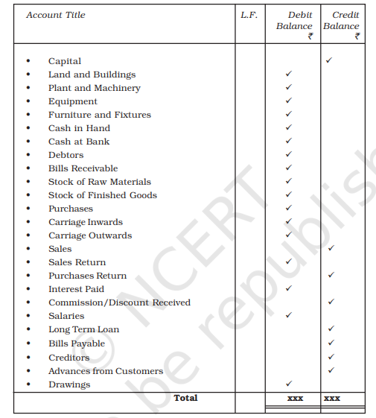

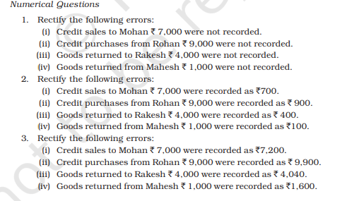

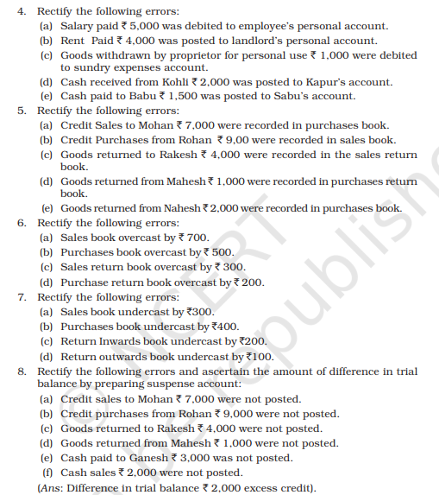

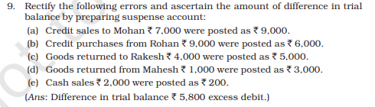

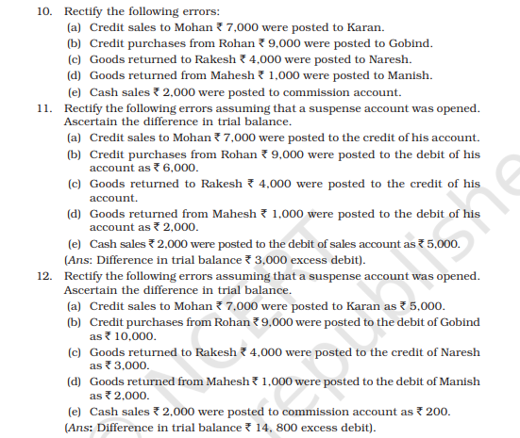

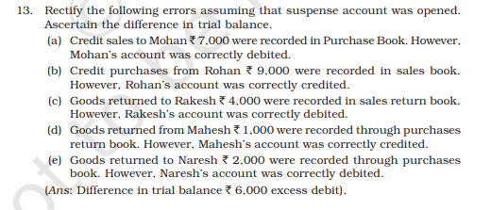

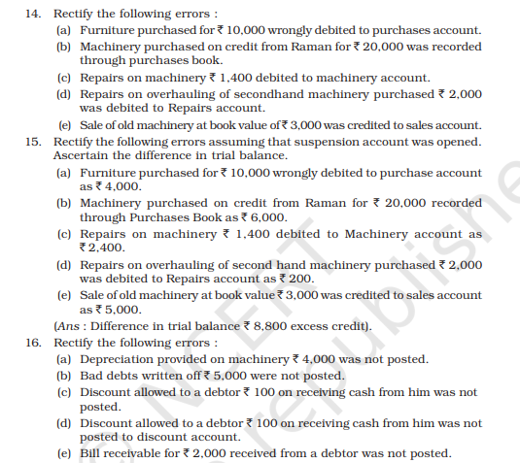

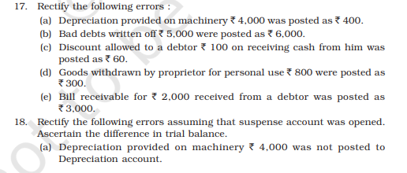

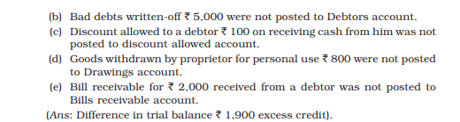

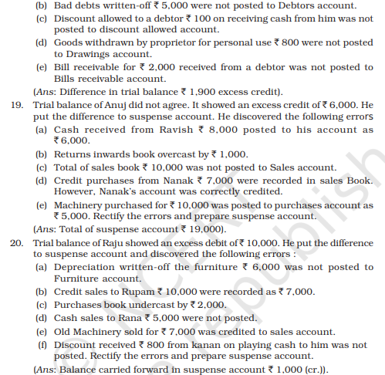

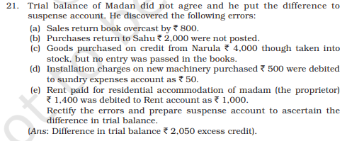

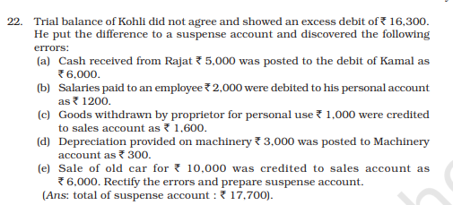

**……………………………………………….**********………………………………………………..**

**KENDRIYA VIDYALAYA AIR FORCE STATION OJHAR**

**WINTER BREAK HOLIDAYS HOME WORK 2021-22**

**CLASS XII : ACCOUNTANCY (055)**

**QUICK REVISION**

**PART A:**

**ACCOUNTING FOR NOT-FOR PROFIT ORGANISATION**

Accounting is always done with respect to an entity. This entity may be either commercial entities or not-for-profit entities. Not-for-profit entities are not engaged in business activities. The main aim is to provide services to the people without an intention of making profit. They stand for achieving social, cultural, educational, religious or charitable objectives. Sports club, Social organizations, religious institutions, hospitals, educational institutions, professional bodies, libraries etc. are the examples of not-for-profit organizations. Some not-for-profit entities may undertake trading activities in order to add the income to its working fund. The income obtained from such activities is used for attaining their objectives. For instance, a sports club may run a stationary shop. The income so obtained can be used for developmental activities of the club.

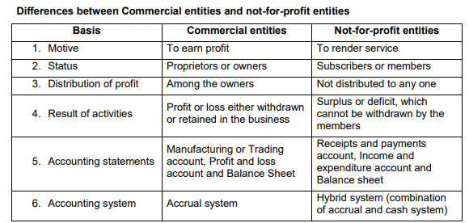

Characteristics

1. Providing service to a specific group such as education, healthcare etc.

2. Organized as charitable trusts or societies and subscribers are called members.

3. Managed by a managing committee elected by the members.

4. Sources of income – subscription from members, donations, legacies, grant-in-aid etc.

5. Funds raised by such organizations are credited to capital fund or general fund.

6. Surplus is not distributed to the members, rather credited to capital fund.

7. They earn reputation not on the basis of customers’ or owners’ satisfaction, but on the basis of their contribution to the welfare of the society.

8. The accounting information provided by such organizations is meant for the contributors and to meet the statutory requirement.

**Accounting Records of Not-for-profit organizations –**

As the not-for-profit organization is a different type of entity, it needs a different type of accounting procedure. They receive money from its members and other agencies to promote their activities, and they want to know from where the funds are generated, how these funds are utilized and whether there is any surplus or deficit. They are required to maintain a stock register with a complete record of assets and consumables. They do not have a capital account; instead, they maintain a capital fund which includes surplus generated, life membership fees, legacies, donations, grant from government etc.

**Final Accounts or Financial Statements :**

These organizations are also bound to prepare their financial statements at the end of each accounting period. Since they are not carrying out any trading activities, they need not prepare trading and profit and loss account. But they would be interested to know whether the income is sufficient to meet the expenses, and is there any surplus or deficit, for this purpose they prepare the following statements:-

1. **Receipt and Payment Account. 2. Income and Expenditure Account. 3. Balance Sheet**

Receipts and Payment Accounts – It includes all cash receipts and cash payments. It is similar to a cash book and hence it serves the purpose of a cash book.

All cash transactions whether revenue or capital in nature are accounted. This account begins with opening cash balance and ends with the closing cash balance. Preparation of Receipts and Payments Accounts – While preparing a Receipts and Payments account, the following points are to be taken into account:

1. This account is always starts with opening balance of cash in hand and cash at bank. Cash in hand always has a debit balance and hence in debit side whereas cash at bank has either debit or credit balance.

2. All receipts made in cash during the accounting year will be shown on the debit side and all cash payments on the credit side. The nature of transaction i.e. capital or revenue and the period to which the transaction may belong i.e. previous year, current year or future year will not be considered.

3. Only actual cash receipts and cash payments are recorded in this account. All non- cash items such as depreciation on fixed assets, outstanding expenses, outstanding incomes, etc. are not recorded.

4. At the end of accounting period, this account is balanced and it shows the closing balance of cash in hand and at bank or bank overdraft.

5. As the receipts and payments account is maintained under cash system, it serves the purpose of a cash book. So that the management is able to know from where cash was generated and how it was utilized. Also it provides necessary information for the preparation of Income and Expenditure account and Balance Sheet.

* **Assignment:**

1. Format of Receipts and Payments Account ,
2. Income and Expenditure Account
3. Balance Sheet of Not-for-Profit organizations

**Treatment of some peculiar items**:

1. Subscription – Current year subscription is to be calculated and it is shown on the credit side of Income and Expenditure Account. Whereas, subscription received for some specific purpose like subscription for tournament fund, subscription for construction of a building etc. should be capitalized and hence shown on the liability side of the Balance Sheet.

2. Donation a. Specific donation – Donation for building, donation for library etc. must be treated as capital receipt and shown on the liability side of balance sheet. b. General donation – Given for general purpose, if it is a large amount it should be capitalized and shown on the liability side and if it is a small amount it can be shown on the credit side of I&E account.

3. Grant received from central govt., state govt. or local bodies for day to day expense are treated as income. But grant for specific purpose like construction of a building is to be capitalized.

4. Legacy – It is the amount received as per the will of a deceased person. It is a capital receipt and shown on the liability side. But if it is a small amount, it may be treated as income. In the absence of specific information, it is preferably be capitalized.

5. Endowment fund – Fund meant for providing permanent means of support. It is a capital receipt.

6. Entrance fee – It is the amount of fees collected on the admission of members. Some Accountants argue that it should be capitalized as it is collected only once (non recurring), but others argue that the organization receives this amount regularly in every year because of regular entry of members, so it should be shown as an income. In the absence of correct information, students may treat it any way, but they must append a note justifying the choice.

7. Sale of old assets – The amount realized from the sale of an asset must be capitalized. But if there is a profit or loss, it should be treated as income or expenditure.

8. Sale of newspapers, periodicals etc. – It should be treated as an income.

9. Expenditure stock items – Items like stationery, sports materials like bats, balls etc. are called expenditure stock items. The value of such items used is considered as expense and the value of unused items are treated as assets.

10.Sale of scrap, grass etc. – These are treated as income.

11.Life membership fee – It is a lump sum amount received from certain members towards life membership instead of annual subscription. It should be capitalized as it is a capital receipt.

12.Special purpose fund – E.g. Tournament fund, Charity fund, Prize fund, Endowment fund etc. If there is any expense or income relating to that fund, it should not be shown in the Income and Expenditure account, but adjusted to that fund on the liability side.

**Precautions to be taken while preparing Income and Expenditure Account**

1. Income and Expenditure account for the year should show the income and expenditure for that year only.

2. If current year’s income includes income of previous year and next year, it must be deducted.

3. If current year’s expenditure includes expenses of previous year or next year, it must be deducted.

4. Generally we assume that outstanding expenses for the previous year must have been paid during the current year. Similarly, outstanding income of the previous year must have been received during the current year.

5. If any income received in advance in the previous year, it should be considered as the income of the current year.

**ACCOUNTING FOR PARTNERSHIP FIRM:**

1. RETIREMENT AND DEATH OF A PARTNER

**Retirement of a partner** means the withdrawal of a partner himself from the business for various reasons such as old age, lack of interest in business etc. A partner can retire from the business either as per the terms of agreement or voluntarily, on retirement he is entitled to get all the sums due to him up to the date of retirement, as well as he is liable for his share in all losses till the date of his retirement.

Accounting Aspects on Retirement

1. Change in Profit sharing ratio.

2. Calculation of gaining ratio.

3. Adjustment regarding goodwill.

4. Adjustment of reserves and accumulated profits/losses.

5. Revaluation of assets and liabilities.

6. Ascertainment of profit or loss up to the date of retirement.

7. Calculation of total amount due to the retiring partner.

8. Settlement of total amount due to the retiring partner.

9. Adjustment of capitals of continuing partner.

**Change in Profit Sharing Ratio**

While retiring a partner the profit sharing ratio of the existing partners may be revised. The share of outgoing partner is often acquired by the existing partners in their profit sharing ratio itself, unless otherwise agreed upon ie; the profit sharing ratio among the remaining partners will not change. Suppose, A,B &C share profits in the ratio of 3 : 2 : 1 and B retires, the ratio between A and C will be 3 : 1, whereas if they decide to be equal partners, the new ratio will be 1 : 1.

Gaining Ratio The ratio in which the continuing partners share the profit of outgoing partner is called gaining ratio.

**GAINING RATIO = NEW RATIO – OLD RATIO :.**

**GAINING SHARE = NEW SHARE – OLD SHARE**

**Treatment of goodwill**

A partner who is retiring from the firm is entitled to his share of goodwill, as it is created by the firm with the efforts of all the partners including the retiring partner. The accounting treatment for goodwill in such a situation depends upon whether goodwill already appears in the books or not.

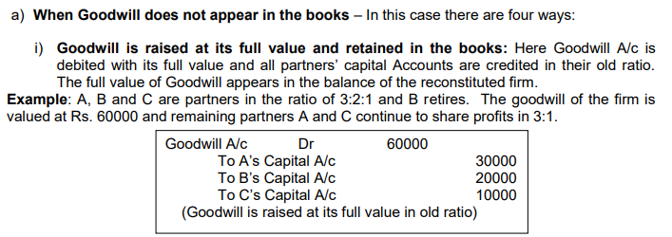

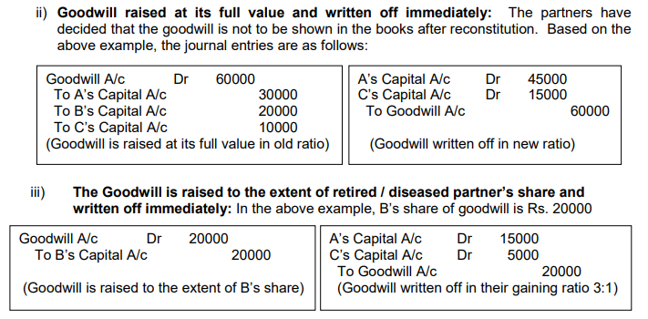

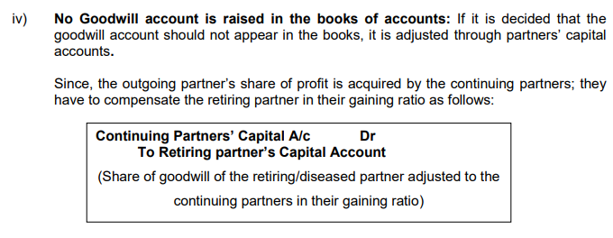

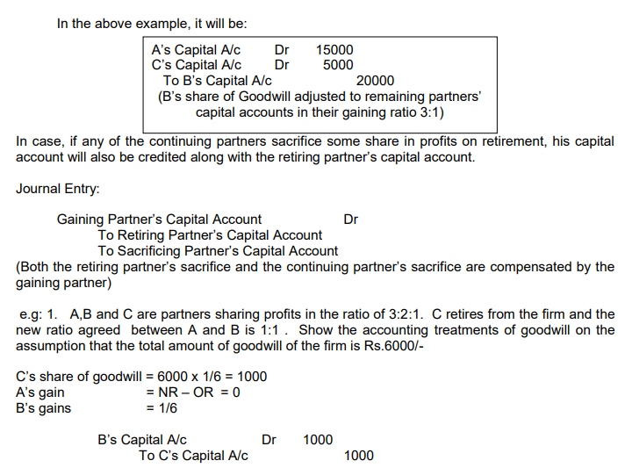

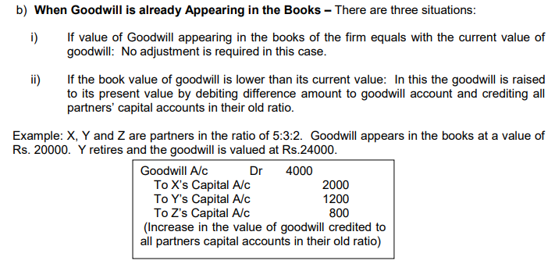

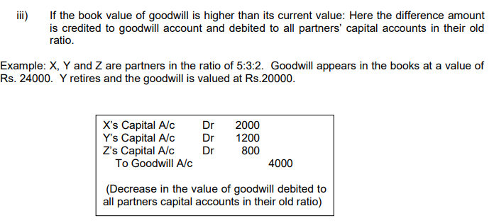

**Revaluation of Assets and Liabilities**

Assets and Liabilities are to be revalued at the time of retirement as in the case of admission of a partner. It is to be done, in order to find out the appropriate share of retiring partner in the firm. It can be done through a revaluation account or profit and loss adjustment account and the profit or loss on revaluation is transferred to all the partners’ capital accounts in their old ratio.

**Accounting treatment –**

similar to admission of a partner Adjustment of Accumulated Profits / Losses General reserve, profit and loss account credit balance and unused reserves like workmen’s compensation fund (in liability side) should be transferred to all partner’s capital accounts in their old ratio. Accounting treatment:

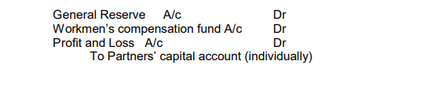

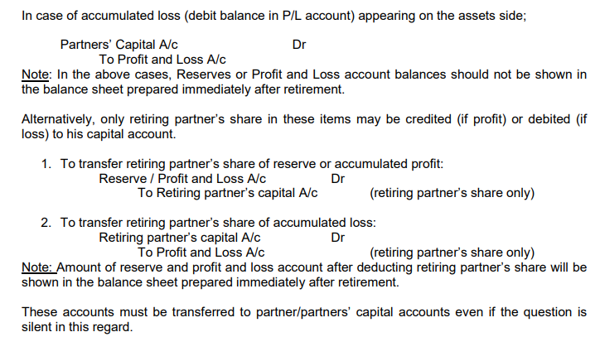

**DEATH OF A PARTNER**

A partnership will come to an end as soon as a partner dies, although the firm may continue with the remaining partners. The accounting treatments for various adjustments in case of death of a partner are similar to that of a retiring partner. However there are some differences between retirement and death.

1. Retirement is planned and which usually takes place at the end of the accounting period. Death may take place at any time.

2. Partner’s connection with the firm is voluntarily broken in the case of retirement. It is automatic in the case of death.

3. Amount payable to the retiring partner is transferred to his loan account. But in case of death it is transferred to the Executor’s account

The amount due to the deceased partner is calculated in the same manner as in the case of retirement and the payment of deceased partner’s share in the firm will be received by his legal representatives.

Most of the accounting treatments are similar to that of retirement. Whenever a firm is not in a position to make the full payment immediately in cash, amount due to the deceased partner is transferred to his Executor’s Loan Account.

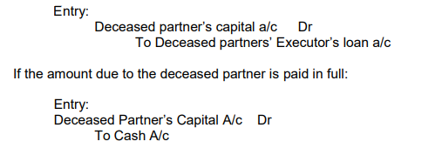

**CH. DISSOLUTION OF PARTNERSHIP FIRM**

According to Section 39 of the Indian Partnership Act, 1932, Dissolution of a firm means the dissolution of partnership between all the partners and no business is being carried out afterwards.

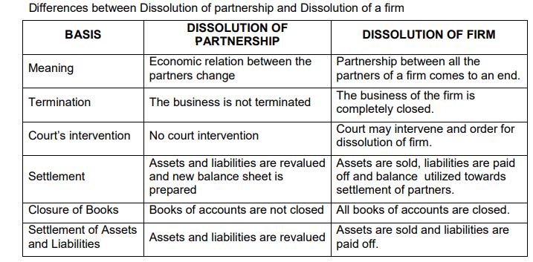

**Dissolution of Partnership**

Dissolution of partnership changes the existing relationship between partners but the firm may continue its business as before.

It may take place in any of the following ways:

1. Change in profit sharing ratio among partners.

2. Admission of a new partner.

3. Retirement of a partner.

4. Death of a partner

5. Insolvency of a partner.

6. Completion of the venture, if partnership is formed for that.

7. Expiry of the period of partnership, if partnership is for a specific period of time.

**Modes of Dissolution of a firm**

**1. Dissolution by agreement (Sec. 40)** – A partnership firm may be dissolved when:

a. All the partners give consent for dissolution.

b. As per the contract between partners.

**2. Compulsory dissolution (Sec.41)** – A firm is dissolved compulsorily in the following cases: a. Where all the partners or all except one become insolvent or insane.

b. Where the business becomes illegal.

c. Where all the partners except one decide to retire from the firm.

d. Where all the partners or all except one partner die.

**3. Dissolution on the happening of certain contingencies (Sec. 42)** –

In the absence of an agreement to the contrary, a firm will be dissolved in the following cases:

a. On the expiry of the term of the firm.

b. On the death of a partner.

c. On the adjudication of a partner as insolvent.

d. On the completion of the venture for which the firm was constituted.

1. **Dissolution by Notice (Sec. 43)–**

In case of a partnership at will, the firm may be dissolved by any partner giving a notice in writing to all the other partners of his intention to dissolve the firm.

**5. Dissolution by Court (Sec. 44)–** A court may order a partnership firm to be dissolved in case of a suit by a partner in the following cases:

a. Where a partner becomes of unsound mind.

b. Where a partner becomes permanently incapable of performing his duties as a partner.

c. Where a partner commits will ful or persistent (continuous) breaches of agreement.

d. Where a partner’s conduct is likely to adversely affect the business of the firm.

e. Where a partner transfers whole of his interest in the firm to a third party without the consent of the other partners.

f. Where the business of the firm cannot be carried on except at a loss.

g. Where the court regards dissolution to be just and equitable.

* **COMPANY ACCOUNTS:**

**ACCOUNTING FOR DEBENTURES**

**Debenture** is a written instrument acknowledging a debt under the common seal of the company. Debenture holders are creditors of the company and get interest at a fixed percent . Debentures are the most common sources of long term borrowed capital of the company.

**Bond:** Bond is also an instrument of acknowledgement of debt. The only difference is with respect of issue condition, i.e, bonds can be issued without pre-determined rate of interest. Traditionally, the Government issued bonds, but these days, bonds are also being issued by semi-government and non governmental organisations.

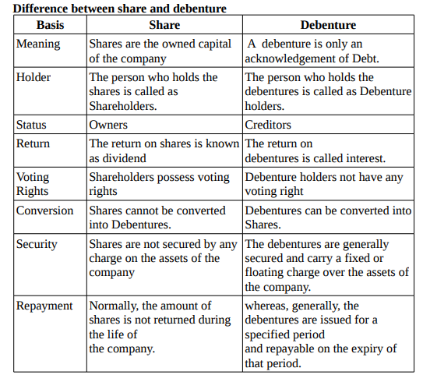

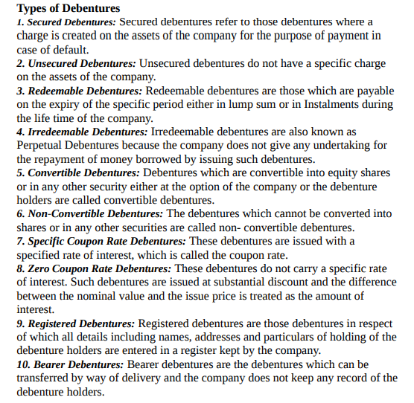

**Issue of Debentures**

The procedure for the issue of debentures is the same as that for the issue of shares.

**Issue of Debentures at a Discount**

When a debenture is issued at a price below its nominal value, it is said to be issued at a discount. Discount on issue of debentures to be written off within 12 months of the balance sheet date or the period of operating cycle is shown under ‘Other Current Assets’ and the part which is to be written off after 12 months of balance sheet is shown under ‘Other Non-Current Assets’.

**Debentures issued at Premium**

A debenture is said to be issued at a premium when the price charged is more than its nominal value. The amount of premium is credited to Securities Premium Reserve account and is shown on the liabilities side of the balance sheet under the head “Reserves and Surpluses”. Issue of

**Debentures for Consideration other than Cash**:

Sometimes a company purchase assets from vendors and instead of making payment in cash issues debentures for consideration thereof. Such issue of debentures is called debentures issued for consideration other than cash.

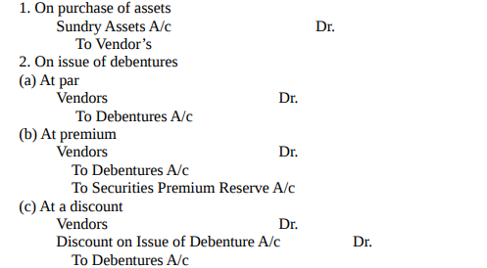

* **Issue of Debentures as a Collateral Security:**

The term ‘collateral security’ implies additional security given for a loan. When a company obtains a loan from a bank or insurance company and the security offered to the company is not sufficient, the company may issue its own debentures to the lender as collateral security against the loan.

* **Writing-off Discount/Loss on Issue of Debentures:**

The discount/loss on issue of debentures is a capital loss or a fictitious asset and, therefore, must be written-off during the life time of debentures.

**PART B:**

**ANALYSIS OF FINANCIAL STATEMENT :**

1. FINANCIAL SATEMENT OF A COMPANY

The financial statements are the end products of accounting process. The statements and accounts which are prepared to ascertain the profit earned or loss suffered and positions of assets and liabilities at a particular date are known as Financial Statements.

As per Sec.2(40) of the Companies Act 2013 the financial statements of a company include:

1. Balance sheet (Position statements)
2. Statement of profit and loss accounts (Income statement)
3. (iii) Cash flow statement

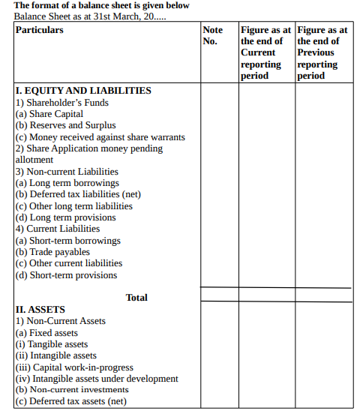

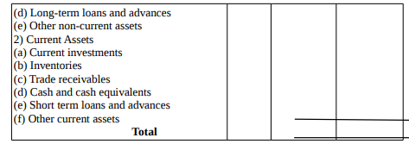

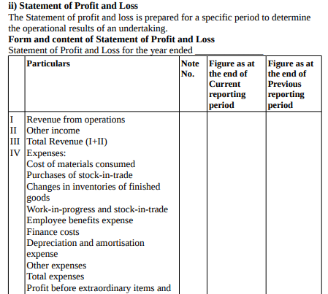



**ASSIGNMENT:**

* Draw the format of **COMPARATIVE AND COMMON SIZE STATEMENT**

**CASH FLOW STATEMENT**

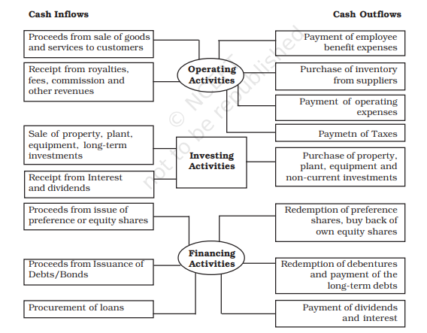

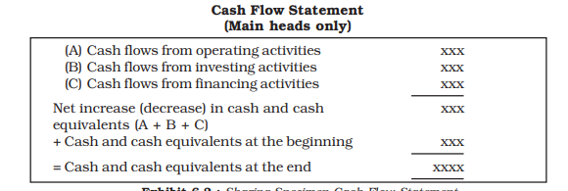

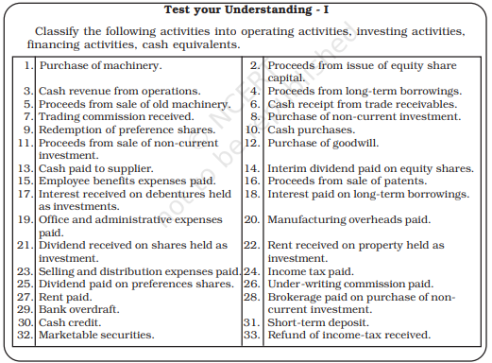

**…………………………………..**********……………………………….**

**KENDRIYA VIDYALAYA AIR FORCE STATION OJHAR**

**WINTER BREAK HOLIDAYS HOME WORK 2021-22**

**CLASS XI: BUSINESS STUDIES (054)**

TERM 2:

**CH.8 Sources of Business Finance**

**QUICK REVISION**







**Long Answer Questions**

1. Explain trade credit and bank credit as sources of short-term finance for business enterprises.

2. Discuss the sources from which a large industrial enterprise can raise capital for financing modernisation and expansion.

3. What advantages does issue of debentures provide over the issue of equity shares?

4. State the merits and demerits of public deposits and retained earnings as methods of business finance.

5. Discuss the financial instruments used in international financing.

**Projects/Assignment**

1.On the basis of the sources discussed in the chapter, suggest suitable options to solve the financial problem of the restaurant owner.

2. Prepare a comparative chart of all the sources of finance

**CH. 9 MSME AND BUSINESS ENTREPRENEURSHIP**

**QUICK REVISION**

Small scale industries contribute significantly to the development process and acts as a vital link in industrialization in terms of production, employment and exports for economic prosperity by widening the entrepreneurial base and use of local raw materials and indigenous skills.

**Types of Small Business**

Business enterprises are classified as Manufacturing Enterprises, Service Enterprises, Village Industries and Cottage Industries. Among these manufacturing and service enterprises are again subdivided into Micro, Small and Medium Enterprises. The definition used by the Government of India to describe small industries is based on the investment in plant and machinery. The Micro, Small and Medium Enterprises Development (MSMED) Act 2006 has been passed by the Government of India to address the issues of small enterprises



SOURCE: NCERT









**Role of Small Business in Rural India**

Small business organizations play an important role in the socio economic development of the country. Some of them are as follows:

a. Multiple sources of income for family.

b. Self employment opportunities in commerce, manufacturing and service segments.

c. Promotion of agro based rural industries.

d. Employment opportunities for artisans and the weaker sections of society.

e. Migration of rural people to urban areas in search of employment has been stopped.

f. Helped to solve the problem of poverty and unemployment.

g. Helped to reduce the income inequalities up to a certain extent.

h. Accelerated industrial growth of the country.

Government Assistance to Small Industries and Small Business Units

Government provides various support measures and programs for the promotion of small and rural Industries, some of them are given below:

**National Bank for Agriculture and Rural Development (NABARD)**

1. • Set up in 1982 for integrated rural development.
2. • Provides finance to small industries, cottage and village industries and artisans.
3. • Offers counseling and consultancy services.
4. • Training and development programs for rural entrepreneurs

**National Small Industries Corporation (NSIC)**

• Set up in the year 1955 to promote and foster the growth of SSIs in India.

• Supply of indigenous and imported machines on hire purchase basis.

• Supply of raw materials – locally and imported.

• Support in export of products. • Monitoring and advisory services.

• Providing latest technology.

• Awareness on technological upgradation.

• Development of software technology parks and technology transfer centres..

**District Industries Centres (DICs)**

• Established in 1978

• To support small entrepreneurs at district level.

• Provides all facilities and support to set up small and village industries.

• Identification of suitable schemes for entrepreneurs by Central and State Govts.

• Preparation of feasibility reports on each industry.

• Arrangement of credit facilities and Equipments.

. • Arrangement of raw materials.

• To impart training for artisans, entrepreneurs etc

**Entrepreneurship Development**

The word entrepreneur is derived from the French verb entreprende, which means to undertake. Entrepreneurship is the process of setting up of one’s own business. The person who sets up the business is entrepreneur and the outcome of the process (business unit) is called enterprise.

“Entrepreneur is a person who organizes the business, undertakes the risk and enjoys the profit” – Richard Cantillon_French Economist.

An entrepreneur is basically a businessman and he brings together the factors of production such as land, labour and capital and organizes it. An entrepreneur is more than a businessman, if a businessman brings some innovation to his activities and eyes on value addition to his products or services, he is called an entrepreneur. In fact, all entrepreneurs are businessmen, but all businessmen are not entrepreneurs.

“**Entrepreneurship** is the purposeful activity of an individual or a group of associated individuals, undertaken to initiate, maintain or organize profit oriented business unit for production or distribution of economic goods and services.

**Start up India Scheme**

Start up India Scheme is an important initiative by Govt. of India to promote a strong ecosystem for nurturing innovation and start up (new enterprises) in the country.

Ways to fund start up

**1. Boot Strapping** – Self financing by the promoters from their personal savings and resources. **2. Crowd Funding** – Pooling resources by a group of people for a common goal especially through internet platforms.

**3. Angel Investment** – Angel investors are the individuals with surplus cash who have keen interest to invest in Start ups. They also offer mentoring or advice along with capital.

**4. Venture Capital –** Venture capitalists provide professionally managed funds to companies and start ups that have huge potential. It is also called risk capital as it is invested in new ventures. Eg: Accel Partners, Blume Ventures etc.

**5. Business Incubators and Accelerators** – Incubators provide funds for Start ups in the early stage of its business, whereas accelerators help the Start ups to run or to take a giant leap in business. Eg: Angel Prime, Khosla Labs, Start up Village etc.

6**. Microfinance and NBFCs** – Microfinance is a category of financial services targeted at individuals and small business who lack access to conventional banking or who have not qualified for a bank loan. Eg: BSS Microfinance P Ltd. , Asirvad Microfinance Pvt. Ltd. etc.

**NBFCs**

**(Non Banking Financial Companies)** are registered under Indian Companies Act and they perform only lending functions to public and they cannot accept demand deposits such as SB A/c, Current A/c etc. Eg: Mahindra & Mahindra Financial Services Ltd., Muthoot Finance Ltd., Bajaj Finance Ltd. etc.

**Very Short Answer Questions**

1. Which year the MSMED Act passed?

2. What is the micro enterprise.

3. What is a cottage industry?

4. What is meant by Village and Khadi Industry?

5. Give any two characteristics of entrepreneurship development.

**Short Answer Questions**

1. What is MSME?

2. State the meaning of entrepreneurship?

3. MSME and Entrepreneurship are connected. Do you agree. Give two reasons.

4. State the role of MSME in development of a country?

5. What are the different parameters used to measure the size of MSME?

6. State the meaning of Village and Khadi industries?

7. State any three major problems faced by MSMEs?

**Long Answer Questions**

1. How do small scale industries contribute to the socio-economic development of India? Discuss

2. Describe the role of small business in rural India.

3. Discuss the problems faced by small scale industries.

4. What measures has the government taken to solve the problem of finance and marketing in the small scale sector?

5. ‘Innovation is integral to MSME’. Discuss giving reasons to your answer.

6. ‘Creativity and Innovation is the key to MSME’. Justify the statement.

…………………………………………………………….***********………………………………………………………………………..

**KENDRIYA VIDYALAYA AIR FORCE STATION OJHAR**

**WINTER BREAK HOLIDAYS HOME WORK 2021-22**

**CLASS XII: BUSINESS STUDIES (054)**

**QUICK REVISION**

**PART A:**

**CH.6 STAFFING**

The term staffing is concerned with the recruitment, selection, placement, training, growth and development of all the members of the organization. Placing the right person on the right job at the right time is called staffing. **Importance of staffing**

1. Competent personnel – Staffing helps to find out competent persons for various jobs.

2. Higher performance by placing the right person on the right job.

3. Survival and growth of the business by providing proper training and development to the future managers.

4. Optimum utilisation of human resources by ensuring the right number of persons on each job positions, i.e., excess or shortage of staff is harmful to the business.

5. Job satisfaction and morale of employees can be improved through proper assessment and remuneration policies.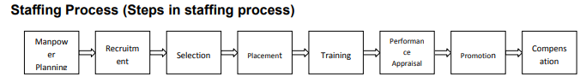

The term staffing is concerned with the recruitment, selection, placement, training, growth and development of all the members of the organization. Placing the right person on the right job at the right time is called staffing.

**Importance of staffing**

1. Competent personnel – Staffing helps to find out competent persons for various jobs.

2. Higher performance by placing the right person on the right job.

3. Survival and growth of the business by providing proper training and development to the future managers.

4. Optimum utilisation of human resources by ensuring the right number of persons on each job positions, i.e., excess or shortage of staff is harmful to the business.

5. Job satisfaction and morale of employees can be improved through proper assessment and remuneration policies.

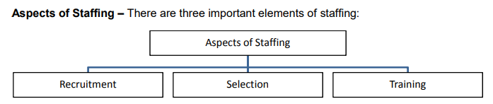

**RECRUITMENT**

Meaning: Recruitment is the process of searching for perspective employees and stimulating them to apply for jobs in the organisation.

Sources of Recruitment Internal Sources – Recruitment from within the organization is called internal sources of recruitment.

SOURCES: TRANSFER AND PROMOTION

**External Sources of Recruitment** –

It refers to the recruitment of candidates from outside the organization.

1. Direct recruitment – Under this method a notice is published on the notice board of the enterprise regarding job vacancies. The candidates are assembled on a particular date and the selection is done on the spot
2. Casual callers from waiting list – Most of the employers are maintaining a database with details of applications received from casual applicants and it may be used as a source of recruitment.
3. Advertisement – It is the most effective means to search potential employees from outside the organization.
4. Employment Exchanges – This is a network of employment exchanges run by the government. Job seekers get themselves registered with these exchanges and their names will be supplied to the business organizations on the basis of their requisition.
5. Placement Agencies and Personnel Consultants – Some specialized agencies in the form of personnel consultancy services have been developed in recent times. These agencies also undertake total functions of recruiting and selecting personnel on behalf of the employer and they charge fees for these services.
6. Campus interviews – Many organizations conduct preliminary search of employees by conducting campus interviews in universities and colleges.
7. Recommendations of Present Employees – Some employers treat the recommendations of their present employees as a useful source of recruitment. This ensures reliability and suitability for the post and it helps in boosting the morale of existing employees.
8. Labour Contractors – This is a method of hiring skilled, semi-skilled and unskilled workers. The contractors keep in touch with a large number of workers and bring them at the places where they are required.
9. Advertising on Television – This method of recruitment is gaining importance these days. The detailed requirements of the job and the qualities required to do the job are published by the organisations through television.
10. Web Publishing – It is now a common source of external recruitment. There are certain sites like www.naukri.com, www.jobstreet.com etc. provide detailed information for both job seekers and job providers.

Advantages of External Sources

1. Qualified and experienced personnel
2. Wide Choice
3. Fresh Talent – infusion of new blood
4. Competitive Spirit - Element of competition with the internal candidates.

**Limitations of External Sources**

1. Dissatisfaction and frustration among existing

2. Time consuming.

3. Very costly.

4. Uncertainty that the qualified and experienced personnel may be appointed.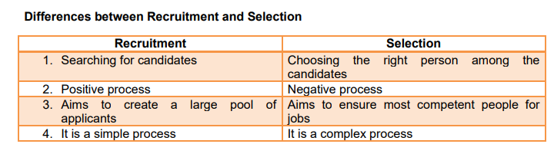

Selection Process

**1. Preliminary screening** – A careful screening of applications is done by a screening committee to eliminate the under qualified candidates.

**2. Selection Test** – Tests are conducted to know the level of ability, knowledge, interest, aptitude etc. of a particular candidate. These tests may be of different types:

**a. Intelligence test** – To measure the level of intelligence.

**b. Trade Test** – This test is conducted to check whether the candidate is suitable for that particular trade. For example, to select a driver, candidates’ knowledge and technical skill in driving are tested.

**c. Aptitude test** – To measure the potential for learning new skills.

**d. Interest test** – To check the interest or involvement of a person on the job. e. Personality test – To evaluate an individual’s emotions, reactions, maturity, values etc.

**3. Interview –** Detailed interviews are undertaken to seek more information from the candidate. This gives the employer to observe the candidate and to assess his level of confidence to take up the job. Usually it is done by an expert interview board.

**4. Checking References** – Reference is a source from which useful information on the candidate can be sought. It may be the names of some outstanding persons, teachers, present employees etc. who know about his experience, skill ability, character etc.

**5. Selection decision** – Final decision is made by the concerned manager based on the performance of the candidates in all the above steps.

**6. Medical Examination** – The physical fitness of the candidates is checked through medical examination. Some organizations undertake medical examination even before testing, for example, armed force, Police etc.

**7. Job offer** – After a candidate has cleared all the above hurdles will be appointed through an appointment letter to join the organisation before a specific date.

**8. Contract of employment** – After the appointment is accepted by the candidate, certain documents are to be executed by the employer and the candidate, in which all the terms and conditions regarding the employment will be specified such as job title, duties and responsibilities, pay scale, allowances, work rules, termination method etc.

**TRAINING & DEVELOPMENT**

**Training** – “Training is the art of increasing the knowledge and skill of an employee for doing a particular job.” Its purpose is to enable them to do their jobs better. A capable and competent person may not do the best on his job unless he is systematically trained.

**Development –** It involves the growth of an employee in all respects, like personality development, motivation for growth, career planning etc. Thus employee development is more future oriented and concerned with education than employee training.

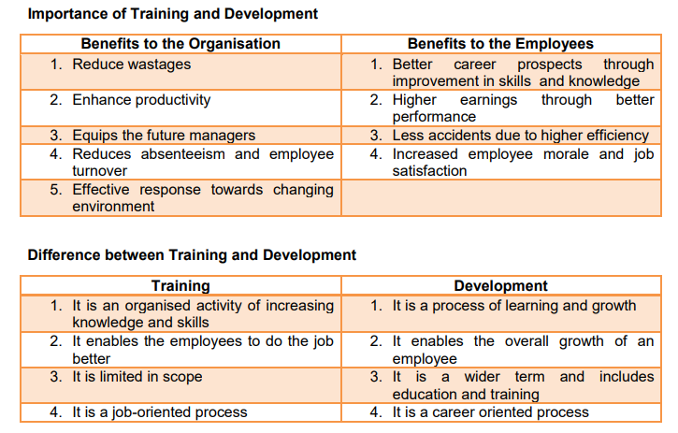

**Training Methods**

**1. On the job Training** – Under this method training is imparted among the employees while they are engaged in their work. Here the employees learn by doing. It includes job rotation, apprenticeship, coaching, committee assignments etc.

**a. Apprenticeship Programmes** – Under this, both knowledge and skills in doing a job are imparted. Here the trainee is put under the supervision of an experienced person in this field. This method is more suitable in electrical work, mining etc.

b. **Coaching** – In this method, a senior manager guides and instructs the trainee as a coach. The coach periodically reviews the progress made by the trainees and suggests change if required.

c. **Internship Training** – According to this, a vocational institute enters into an arrangement with a business enterprise to provide practical knowledge to its students. It is intended for providing practical experience to the students in their fields. For example, MBA students are directed to undertake project work in business enterprises, engineering students are sent to big industrial enterprises to gain practical work experience, Medical students to hospitals etc.

d. **Job Rotation** – The trainee is systematically shifted to various jobs so that he can gain the experience on each of them.

**2. Off the Job Training** – This is concerned with imparting training to employees outside the actual work place. The methods adopted include class room lectures, conferences, case study methods, films, TV shows, etc. The employees can concentrate on training alone since they are away from the work place.

a. Classroom lectures / conferences – It is suitable to convey information, rules, procedures and methods.

b. Film shows – It can be used to provide information through demonstration.

c. Case study – Cases are actual experiences which managers confronted while discharging their duties. Trainees are asked to study the case and to determine the problems and their solutions.

d. Computer modelling – With the help of computer programming the realities of jobs are imitated and the trainees get an opportunity to familiarise the situation, so that they will be able to minimise the mistakes in real job situations. E.g., a computer model can be used to test how safe the design of the car is in a crash, building demolition etc.

e. Vestibule Training – In this case an actual work situation is created in a classroom. Employees use the same materials and equipment for training. f. Programmed instructions – This is a method of presenting a new subject to the trainees in a graded sequence (simple to complex). Trainees work through the programmed material (text books or computer programs) by themselves at their own speed and after each step test their comprehension by answering some question

**CH.7 DIRECTING:**

**DIRECTING Meaning**: Directing is the process of activating human resources to achieve the objectives of the business. The word directing literally means moving into action. According to Earnest Dale,

“Directing is telling people what to do and seeing that they do it to the best of their ability.

**” Characteristics of Directing**

1. Initiates action – Directing gives a starting for all actions in the management.

2. Pervasive – This function takes place wherever superior – subordinate relationship exists, i.e., in all the levels of management.

3. Continuous process – It carried out through the life of the organization.

4. Flows from top to bottom – It implies that managers can direct the subordinates.

5. Human element – Directing is concerned with the human beings in the organization.

**Importance of Directing**

1. Directing initiates action – Through direction management conveys and motivates individuals to perform in the desired way to achieve goals.

2. Integrates employees’ efforts – It is very necessary to coordinate and integrate the activities of all the people in the organization. If their efforts are not integrated properly, the business cannot achieve its objectives successfully.

3. Means of motivation – In order to get the best result from business, it is necessary to motivate the workers to contribute their best and it is possible through proper motivation.

4. Provides stability and balance in the organization – Direction coordinates and integrates the individual goals and organizational goals so as to achieve maximum results. Effective leadership, supervision, motivation and communication provide stability and balance in the organization.

5. Facilitates changes in the organization – Business environment is highly flexible and changing, most of the employees prefer to remain indifferent to new ideas and techniques and unwilling to implement changes. Only through effective direction and motivation they will be induced to accept changes and challenges of their job pleasantly.

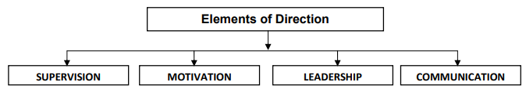

1. **Supervision** – The term “supervision” is derived from two Latin words – “Super” and “Vision”. Super means over and above and vision means to see. Thus supervision means “Overseeing the activity”. In management, supervision means overseeing the subordinates at work. It refers to direct and immediate guidance and control of subordinates in performing their tasks in accordance with the plans and policies of the enterprise. The person who supervises the subordinates is called “Supervisor”. He is also known as Foreman, Overseer, Superintendent, Section officer etc.
2. **Motivation** – “Motivation means a process of stimulating people to action to accomplished goals.”

**Maslow’s Need Hierarchy Theory of Motivation** :

Motivation is based on human needs. To motivate means to satisfy human needs. However, needs take a hierarchy as given by Maslow’s theory on need hierarchy. To motivate the employees, the manager has to understand the needs and wants of the employees. The behavior of an individual at a particular moment is usually determined by his strongest need. Famous Psychologist Abraham H Maslow developed a conceptual framework for understanding the nature and strength of human needs.



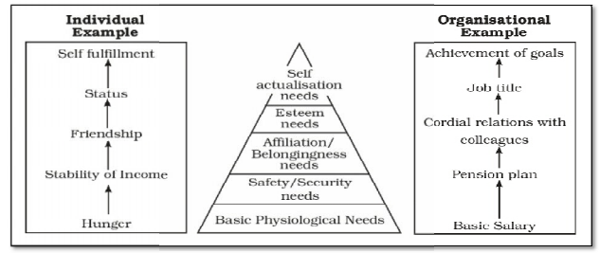

1**. Basic Physiological Needs** – These are the basic needs of an individual like food, clothing and shelter. Unless these needs are met, a higher level need will not arise, the majority of a person’s activities will probably be directed towards satisfying them.

2**. Safety and Security Needs** – These are the needs for safety and protection against hazards and dangers. People in the organization want job security, personal bodily security, security of source of income, provision for old age, insurance against risks etc.

3**. Social Needs (Affiliation/ Belonging needs)** – These are the needs for love and affection, friendship, a sense of belonging etc. On meeting safety and security needs, social needs come in. Since man is a social being, he has a need to belong and to be accepted by various groups.

4. **Esteem Needs** – These needs are the desire for status, prestige, dignity, self-respect, independence, respect from others etc. The organizations can satisfy these needs by recognizing and appreciating good performance, promotions etc.

5**. Self Actualization Needs** – Self actualization is the need to maximize one’s potential, whatever it may be. In other words it is an urge to use one’s potentialities for the achievement of life ambition.

**Incentives**:

In order to satisfy the needs and to motivate the employees, managers offer various incentives. Incentive means all measures which are taken to motivate employees to improve their performance.

**Financial and Non Financial Incentives**

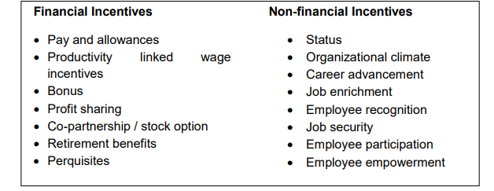

**Co-partnership / Stock option** – Under this system some of the employees are offered to subscribe the shares of the company at a discounted rate than the market price. By this they are becoming the part of owners which will highly motivate such employees. Wipro, Infosys, TCS etc. are following this system.

1. **Leadership** :“Leadership is the ability of a manager to induce subordinates to work with confidence and zeal” – Koontz and O’Donnell. (Zeal means passion or enthusiasm)

**Leadership Styles** Depending on the use of authority, there are three basic styles of leadership:

**(i)Autocratic (ii) Democratic, and (iii) Laissez-faire**

1. An autocratic leader gives orders and expects his subordinates to obey those orders. This leadership style is effective in many situations like in a factory where the supervisor is responsible for production on time and has to ensure labour productivity.
2. A democratic leader will develop action plans and makes decisions in consultation with his subordinates. He will encourage them to participate in decision making. This kind of leadership style is more common now-a-days.
3. Laissez faire or Free-rein leader does not believe in the use of power unless it is absolutely essential. The followers are given a high degree of freedom to formulate their own objectives and ways to achieve them.
4. **Communication**

The term communication has been derived from the Latin word “Communis”, which means “Common”. Communication may be defined as an exchange of ideas, facts, opinions and emotions from one person to another to create mutual understanding.

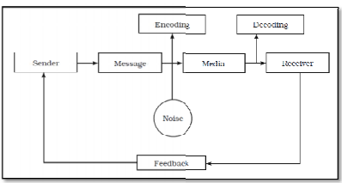

**Elements of Communication Process**

1. Sender – is the person who sends a message. He initiates the process of communication.

2. Message – is the subject matter of communication consists of words, facts, ideas etc.

3. Encoding – In order to transmit an idea, the sender translates the idea into meaningful languages like words, actions, pictures, diagrams, gestures etc.

4. Media/Channel – It is the medium through which the message is passed. Eg: face to face talk, telephone, letter, radio, television etc.

5. Decoding – Receiver converts the symbols received from the sender to give him the meaning of the message.

6. Receiver – is the person or a group who is supposed to receive the message. Eg: Listener, reader, observer etc.

7. Feedback – It means the reaction, replay, response which the receiver sends to acknowledge his understanding.

Communication taking place in an organization may be classified as follows:

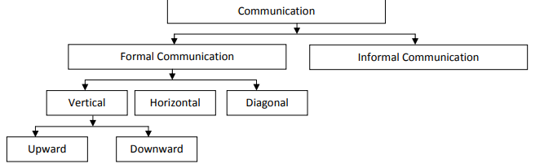

**Formal Communication** – Communication through the official chain of command is called formal communication. Thus, formal communication flows through the scalar chain of authority. Generally it may takes place in the form of written communication such as notes, memos, letters, reports etc.

**1. Vertical Communication** – Communication flows vertically, i.e., upward or downward. a) Upward Communication – It refers to flow of communication from lower level to higher level. It consists of information relating to subordinates’ work performance, opinion, suggestions, complaints etc. b) Downward Communication - It refers to flow of communication from higher level to lower level. There are many ways in which a superior can communicate with his subordinates like Notices, Circulars, Memos, Reports, Meetings etc.

**2. Horizontal Communication** – Transmission of information among the persons of the same level and status is known as horizontal communication. Flow of information from the Purchase Manager to the Production manager is an example for horizontal communication.

**3. Diagonal Communication** – Communication between people in different departments, one holding a higher position than the other. If a sales executive requests the production manager to improve the quality of the product, it forms a diagonal communication. Though it violates the principal of unity of command, it will help to save time and to speed up action.

**Informal Communication :**

Informal communication is based on informal relationship among the members of an organization at same or different level. This is free from all formalities of formal communication. It is usually oral and is conveyed by gestures, a glance, smile etc. It may involve work related or other matters of mutual interest. Informal communication often supplements formal communication.

**Grapevine** : The network or pathway of informal communication is called grapevine. The origin and direction of flow of information cannot be easily traced. Grapevine is structure less and it grows towards all direction.

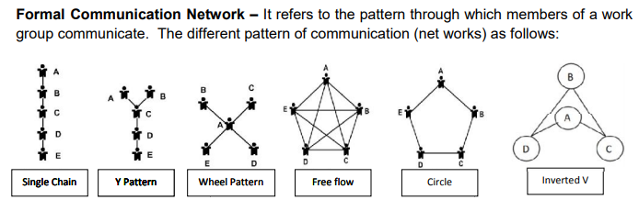

1. **Single Chain** – In this pattern, the persons at the two extremes interact with one person and all other members communicate with two each, i.e., from superior to subordinates.

2**. “Y” Pattern** – This pattern is slightly centralized. Some persons are closer to the centre of the network. E.g., A, B and D and are closer to C than E.

3. **Wheel Pattern** – here communication flows from one central person, who is generally the group leader. In this case, communication initiates from A and all other members can communicate through “A” alone. Communication between B to C, C to D etc. is not possible.

4**. Free flow** (All Channel Pattern) – This pattern permits all the members to communicate with each other in the group. This is the most decentralized form of communication network.

5. **Circle Pattern** – This pattern permits each person in the group to communicate with two in the group.

6. **Inverted V Pattern** – Here a subordinate is allowed to communicate with his immediate superior as well as his superior’s superior

**Single strand** –

1. **Single line** – each person communicates to the other by keeping a strict sequence.

2. **Gossip** – each person communicates with all others on non-selective basis.

3**. Probability** – individual communicates with other individual on a random basis.

4. **Cluster** – here the individual passes information to only those persons in whom he has trust.

**CH.8 CONTROLLING**

**Meaning Controlling** is the process through which management ensures that the actual performance conforms to the planned performance. It discovers deviation from the results expected. It also identifies the reasons for deviations and suggests suitable action to avoid their recurrence in future.

**Importance / Advantages of Controlling**

1. Accomplishing organizational goals – It measures actual performance with standards and making corrective actions on deviations, so that the organization can achieve its goals smoothly.

2. Judging accuracy of standards – Controlling helps to check the accuracy of standards in changing environment, which helps to revise the standards if needed.

3. Efficient use of resources – Controlling seeks to reduce wastages of resources.

4. Improving employee motivation – Controlling ensures employee awareness regarding what is expected to do and what is the standards fixed on him, so that he will be motivated to give better performance.

5. Ensures order and discipline – Controlling ensures an order and discipline as there is a close watch on the activities of all employees.

6. Coordination – In order to coordinate the activities of different persons and departments, an effective system of control is necessary.

7. Decision making – The process of control is complete when corrective actions are taken. It will lead to make better decisions in future.

**Relationship between Planning and Controlling** –

The entire planning process will turn to be waste unless adequate control measures are exercised. The relationship between planning and control may be summed up as follows:

**a. Planning and control are interdependent and inseparable functions of management**. Without a plan there is nothing to control. Thus planning is useless without control and controlling is useless without plan.

**b. Planning and controlling are interrelated and in fact reinforce each other in the sense that**: • Planning makes controlling easier and effective. • Controlling reveals the shortcomings of plans and calls for improvement in future.

**c. Planning is looking ahead while controlling is looking back** –

Planning is a forward looking function as plans are prepared for future period. Whereas, controlling is a post-mortem of past activities to find out the deviations, so that it is a backward looking function of management. However, some people argues that, controlling is a also a forward looking function as it provides valuable information of past experience for future planning.

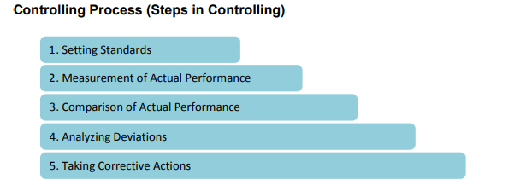

1. **Setting performance Standards** – In order to achieve the goals, standards of performance have to be determined in planning itself.

**Quantitative Standards** - As far as possible, standards must be in concrete and tangible forms which will make evaluation process easy. For example, the profit expected from a particular product, time required for completing a task, cost of production for one unit is Rs.100 etc. Qualitative Standards - Standards can also be in intangible forms. The results expected from a training programme, loyalties of workers, Improving motivation level of employees, etc. are the examples for qualitative standards.

1. Measurement of actual performance – The second step is to measure actual performance of employees or departments. It should measure actual performance of each activity in terms of quality and quantity.
2. Comparison of actual performance with standards – Comparison of actual performance with the standards reveals the deviations between actual and desired results.
3. Analyzing deviations – At this stage, the extent of deviations and causes of such deviations are to be found out. It is important to ascertain whether deviations are within the expected range. Deviations in key areas of business require urgent attention. Managers can rely on the following in this regard.

**a. Critical Point Control** – The control measures should be focused on key result areas (KRAs) which are critical in the success of an organization. These KRAs are the Critical Points, if anything goes wrong at this critical point, the entire organization will suffer. Example: 5% increase in labour cost is a serious matter than 20% increase in postal charges.

**b. Management by Exception (MBE) / Control by Exception** –

All deviations need not be brought to the attention of top management. Only those deviations which seem exceptionally high and which cannot be easily solved by lower level management alone should be reported to top management. Example: 2% increase in the material cost (if it is within the permissible limit) need not be reported, whereas, if it is far beyond the limit, say 10% increase, it requires immediate attention of management on a priority basis. In other words, the top level management is concerned with highly exceptional matters only and the routine matters will be handled by the lower levels.

1. **Taking corrective actions** – As soon as deviations are reported, it is the duty of the executives to take steps to correct the past action so that deviations may not occur again and the plans are properly executed. If there is no deviation or if the deviation is within the permissible limit, let the situation remains as it is. At times, the deviations may be such that which cannot be rectified and beyond the control of management, they may take necessary decisions by modifying the goals and standards.

**PART B:**

**CH.10 : FINANCIAL MARKET**

**Meaning** – Financial market is a market for the creation and exchange of financial assets such as shares, debentures, bonds and government securities. It is a network of institutions which provide short, medium and long term funds. Financial markets make possible the transfer of money from the investors to the entrepreneurial borrowers. Actually they bring together the lenders of funds and borrowers of funds.

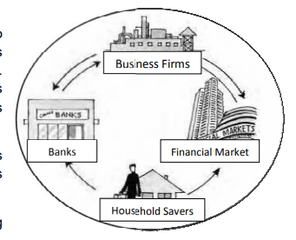

**Functions of financial market**

1**. Mobilize savings and channelize them into most productive purposes** – It offers the investors different investment avenues and helps to channelize surplus funds into productive use.

2**. Price discovery** – Price of any product is determined by the forces of demand and supply. The interaction between savers(investors) and business firms facilitates the price determination for the financial assets, which is being traded in a particular market.

**3. Providing liquidity** – Financial markets provide liquidity to financial assets as they can be converted into cash by selling them in the market very easily.

**4. Reducing cost of transaction** – Financial markets provide a common platform where buyers and sellers meet and to trade their securities without much cost and time.

Financial markets are mainly of two types:

Money market (Market for short term funds) and Capital market (Market for medium and long term funds)

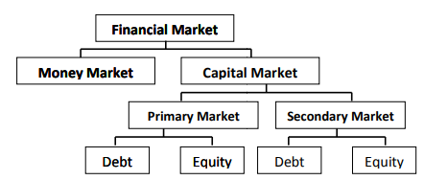

**Money Market** – Meaning Money market is the market for short term funds. Short term funds are meant for a period of up to one year. Money market is not usually located at a particular place. It is a term used to describe all organizations and institutions that deal in short term debt instruments.

It makes possible the raising of short term funds for meeting the working capital needs and temporary deployment of excess funds to get returns.

**Money market instruments**

1. **Treasury Bills (T-Bills / Zero Coupon Bonds)** – These are issued by RBI on behalf of Central Government. Maturity less than one year. It is an instrument for short term borrowings by Government of India. They are issued in the form of promissory notes and freely transferable as it comes under Negotiable Instrument Act They are issued at a price which is lower than their face value and repaid at par, the difference between issue price and redemption value is called discount. It is available for a minimum amount of Rs. 25,000 and in the multiples thereof.

2**. Commercial Paper (CP**) – Issuing commercial paper in India as a money market instrument took place in 1989-90. It is an unsecured promissory note issued to the public with a fixed maturity period ranging from 15 days to 1 year. Since being unsecured, this is issued by highly reputed corporate entities. This serves as an important source of working capital and for bridge financing for raising long term funds from capital market in order to meet flotation cost, brokerage, advertising, printing share applications etc. Commercial banks and mutual funds contribute towards this kind of instruments.

3**. Call Money** – This is an important part of money market where day-to-day surplus funds of banks and other financial institutions are dealt with. The banks with surplus funds lend other banks that are facing deficiency. The duration of call money caries from one day to 15 days and is repayable on demand, either by the lender or by the buyer. Interest paid on call money is called Call rate. Call money is a method by which banks borrow mutually to maintain CRR (Cash Reserve Ratio), CRR is the minimum balance a commercial bank should maintain with RBI.

4. **Certificate of Deposit (CD) –** It is an unsecured, negotiable, short term instrument in bearer form, issued by commercial banks and financial institutions to individuals, corporations and companies. Maturity period 3 months to 12 months. These are issued at a discount and redeemed at par.

5. **Commercial Bill (Trade Bill**) – This is a bill of exchange used to finance working capital requirements of a business. It is a short period, negotiable and self-liquidating instrument used to finance credit sales.

**Capital Market** – Meaning Capital market is an institutional arrangement by which savings are channelized into investment avenues. It enables the borrowers to raise funds for their purpose. Similarly, it gives opportunities to the lenders to wisely invest their funds. The borrowers raise required funds through issue of securities like shares, debentures, bonds etc. A security means a certificate of title evidencing investment made in the capital or debt of any entity.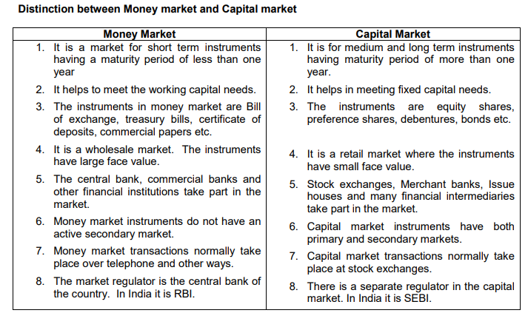

**Capital market consists of two major segments, namely, primary market and secondary market**.

Primary Market (New issue market) This is the market which deals in new securities issued by new companies or existing companies. Therefore, it is also called New Issue Market (NIM). If it is issued by new companies it is called Initial Public Offerings (IPOs) and if it is issued by existing companies it is called Seasoned Equity Offerings (SEOs). The securities offered are equity shares, preference shares, debentures, bonds, innovative types of securities like deep discount bonds, zero interest bonds etc.

**Methods of flotation of new issue**

1. **Offer through prospectus** – It is the most common form of raising capital from the primary market. Prospectus is an invitation for subscription or purchase of shares or debentures of a company.
2. **Offer for sale –** This is an indirect method of public issue. Securities are offered to an issue house or other intermediaries like brokers through a “letter of offer” at a negotiated price. They, in turn, will sell them to the public generally at a higher price, by means of advertisement of their own. This enables the company to get funds in advance and they are relieved from the tedious process of public issue.
3. **Private placement** – It means the direct sale by a company of its securities to a limited number of specified investors. Here the issuing company may appeals to selected investors to subscribe to or purchase the securities either directly or through brokers. The main advantage of this method is that there is no risk of uncertainty in raising capital and it is a cost effective method of raising finance as compared to public issue.
4. **Rights issue** – It is a method of raising additional capital from existing shareholders by offering equity shares or debentures on pro-rata basis. This is known as ‘pre-emptive right’. According to Companies Act, if a public company wants to issue additional shares, it must first be offered to the existing shareholders, in proportion to the amount paid up on those shares. When the issue price is less than market price, the rights have a market value.
5. **e-IPOs -** In case a company wishes to issue capital to the public through on-line system should enter into an agreement with the stock exchange. This method of new issue is called e-IPOs.

**Secondary Market (Stock Exchange)** Secondary market is the market for the purchase and sale of second hand or listed securities. Shares, debentures, bonds etc. which have already been issued by companies or government are traded in this market. It consists of buyers and sellers of securities and brokers as intermediaries. The investors can buy and sell securities only through brokers. Secondary markets are also known as stock exchanges.

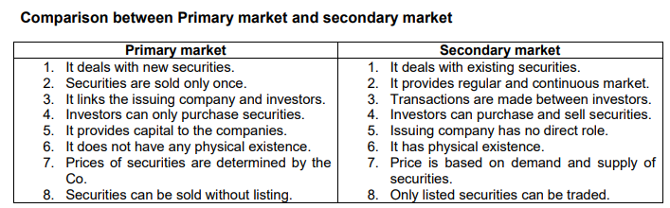

**Secondary Market (Stock Exchange):**

Secondary market is the market for the purchase and sale of second hand or listed securities. Shares, debentures, bonds etc. which have already been issued by companies or government are traded in this market. It consists of buyers and sellers of securities and brokers as intermediaries. The investors can buy and sell securities only through brokers. Secondary markets are also known as stock exchanges.

S**tock exchanges are located at definite places.** Trading in securities takes place inside the stock exchange at a place known as the trading ring. Only the members (brokers) are authorized to trade here. In the traditional method of trading on the ring, trading actually resembles an auction. Brokers of intending sellers and buyers will shout quoting their prices. When the prices coincide, a deal will be struck. Online trading in securities is facilitated through a computer network wherein one can buy or sell securities just by sitting in front of the broker’s computer. Computer will match the buyer’s quotation and a deal is struck.

**Functions of stock exchanges**

1. **Liquidity and marketability to investment** – Secondary market provides a continuous market to the listed securities, so that investors enjoy liquidity to their investment. They could sell securities with them and buy another.
2. **Pricing of securities** – A security is issued in the market at a price known as the issue price. Over a period of time, it reaches its true level through the interaction of the forces of demand and supply in stock exchange.
3. **Safety of transactions –** The rules and regulations ensures safety and fair dealings to investors.
4. **Contributes to economic growth** – through capital formation.
5. **Spreading of equity cult (trend)** – Stock exchanges can take effective measures in educating public about investments.
6. **Providing scope for speculation** – A reasonable degree of healthy speculation is needed to ensure liquidity and price continuity in securities.
7. **Economic barometer** – Business conditions like booms and depressions, important events; both national and international will affect the stock prices. In this sense we can say that the stock exchange is an economic barometer (indicator).

**Bombay Stock Exchange (BSE) Established in the year 1875** – Voluntary non-profit association – oldest in Asia – 1 st one recognized by government – only one that has been granted permanent registration – premier stock exchange – trendsetter in stock market trading – companies having at least Rs.10 crores are eligible to be listed in BSE – About 6000 scrips listed – securities are classified into many groups like group A, B, T and Z. A group contains securities having good track record and large volume of business – traditionally trading was carried on outcry system – in 1995 it introduced a screen based trading called BOLT (BSE On-Line Trading). At present BOLT has a nationwide network.

**Securities and Exchange Board of India (SEBI)** SEBI is the regulatory and developmental agency of Indian Capital Market, established in 1988 based on the recommendations of G S Patel Committee. It was made a statutory body under Securities and Exchange Board of India Act 1992.

**Objectives of SEBI**

1. Regulatory functions - To regulate the securities market and ensure fair practices.

2. Protection of rights - To protect the interest of investors and thereby attract a steady flow of savings into capital market.

3. Prevention of malpractices – To prevent trading malpractices.

4. Develop a code of conduct - To promote efficient services by brokers, merchant bankers etc. so as to make them competitive and professional.

**Functions of SEBI**

**A. Regulatory functions:**

1. Registration of brokers and sub brokers in the market.

2. Registration of investment schemes and Mutual Funds.

3. Regulates the functioning of share brokers, underwriters etc.

4. Regulation of takeover bids by companies.

5. Conducting enquiries and audits of stock exchanges.

6. Levying fee or other charges as specified by the Act.

**B. Developmental functions**:

1.Promoting investor education and training of intermediaries.

2. Conduct of research and publication of useful information.

3. Undertaking measures to develop the capital market.

**C. Protective functions**:

1. Prohibition of fraudulent and unfair trade practices like misleading statements, manipulations, price rigging etc.

2. Controlling insider trading in securities to protect the interest of individual investors. Insider means the top officials of the company, who can make bulk purchase or sale for making huge profit on the basis of vital information such as declaration of dividend on a future date etc.

3. Undertaking steps for investor protection.

4. Promotion of fair practices and code of conduct in securities market.

……………………………………………………………………********………………………………………………………………………….

**HHW Economics**

**Class XII**

1. Calculate the net value added at the market price of a firm:

|  |  |
| --- | --- |
| **Items** | **Amount** |
| Sale  Change in stock  Depreciation  Net indirect taxes  Purchase of machinery  Purchase of an intermediate product | 400  -20  30  40  200  250 |

1. Calculate the nominal income and private income from the following data.

|  |  |
| --- | --- |
| **Contents** | **₹. (in crores)** |
| Net current transfers from the rest of the world | 10 |
| Private final consumption expenditure | 600 |
| National debt interest | 15 |
| Net exports | -20 |
| Current transfers from the government | 5 |
| Net domestic product at factor cost accruing to the government | 25 |
| Government final consumption expenditure | 100 |
| Net indirect tax | 30 |
| Net domestic capital formation | 70 |
| Net factor income from abroad | 10 |

1. **Calculate private income, personal income, personal disposable income and** **National disposable income from the following data:**

|  |  |  |
| --- | --- | --- |
|  | | (Rs. in Crores) |
| (i) | National income | 3000 |
| (ii) | Savings of private corporate sector | 30 |
| (iii) | Corporate tax | 80 |
| (iv) | Current transfer from government | 60 |
| (v) | Income from property and entrepreneurship to government | 150 |
| (vi) | Current transfers from rest of the world | 50 |
| (vii) | Savings of non-departmental government sector | 40 |
| (Viii) | Net indirect taxes | 250 |
| (ix) | Direct taxes paid by household | 100 |
| (x) | Net factor income from abroad | (-) 10 |

4. **Calculate NI by income and expenditure method:**

|  |  |  |
| --- | --- | --- |
|  | | (Rs. in Crores) |
| (i) | Subsidies | 5 |
| (ii) | Private final consumption expenditure | 100 |
| (iii) | NFIA | (-) 10 |
| (iv) | Indirect Tax | 25 |
| (v) | Rent | 5 |
| (vi) | Government final consumption expenditure | 20 |
| (vii) | Net domestic fixed capital formation | 30 |
| (viii) | Operating surplus | 20 |
| (ix) | Wages | 50 |
| (x) | Net export | (-) 5 |
| (xi) | Addition to stock | (-) 5 |
| (xii) | Social security contribution by employers | 10 |
| (xiii) | Mixed income | 40 |

5. **Estimate the following with the help of given data:**  
**(i) GDPMP ,**  
**(ii) Net Value Added at factor cost; and (iii) prove that it is equal to the income generated.**

|  |  |  |
| --- | --- | --- |
|  | | (Rs. in Crores) |
| (i) | Increase in the stock of unsold goods | 1000 |
| (ii) | Sales | 10,000 |
| (iii) | Net indirect tax | 800 |
| (iv) | Purchase of raw materials from other firms | 1650 |
| (v) | Purchase of fuel and power | 850 |
| (vi) | Consumption of fixed capital | 500 |
| (vii) | Rent | 700 |
| (viii) | Wages and salaries | 3500 |
| (ix) | Interest payment | 1000 |
| (x) | Dividend | 1500 |
| (xi) | Corporate gain tax | 300 |
| (xii) | Undistributed profit | 200 |